UNITED STATES
SECURITIES AND EXCHANGE COMMISSION
Washington, D.C. 20549

FORM 6-K

REPORT OF FOREIGN PRIVATE ISSUER
PURSUANT TO RULE 13a-16 OR 15d-16
UNDER THE SECURITIES EXCHANGE ACT OF 1934
For the month of October, 2026.
Commission File Number: 001-14946

Cemex, S.A.B. de C.V.
(Translation of Registrant’s name into English)

Avenida Ricardo Margáin Zozaya #325, Colonia Valle del Campestre,
San Pedro Garza García, Nuevo León 66265, México
(Address of principal executive office)

Indicate by check mark whether the registrant files or will file annual reports under cover Form 20-F or Form 40-F.
Form 20-F ☒ Form 40-F ☐

Contents

1. |  | Press release dated October 26, 2026 announcing third quarter 2026 results for Cemex, S.A.B. de C.V. (NYSE: CX) (“Cemex”).
2. |  | Third quarter 2026 results for Cemex.
3. |  | Presentation regarding third quarter 2026 results for Cemex.

SIGNATURE
Pursuant to the requirements of the Securities Exchange Act of 1934, Cemex, S.A.B. de C.V. has duly caused this report to be signed on its behalf by the undersigned, thereunto duly authorized.

 |  |  |  |  |  | Cemex, S.A.B. de C.V.
 |  |  |  |  |  | (Registrant)
Date: October 26, 2026 |  |  |  | By: |  | /s/ Jaime Martínez Merla
 |  |  |  |  |  | Name: Jaime Martínez Merla
 |  |  |  |  |  | Title: Chief Comptroller

3

EXHIBIT INDEX

EXHIBIT  NO. |  | DESCRIPTION
1. |  | Press release dated October 26, 2026 announcing third quarter 2026 results for Cemex, S.A.B. de C.V. (NYSE: CX) (“Cemex”).
2. |  | Third quarter 2026 results for Cemex.
3. |  | Presentation regarding third quarter 2026 results for Cemex.

4
Exhibit 1


Cemex reports strong third quarter EBITDA growth with year-to-date Free Cash Flow from Operations almost tripling

 |  |  | For the quarter, sales grew 8%, EBITDA grew 12%, and EBIT grew 19%

 |  |  | Record third quarter Free Cash Flow from Operations of US$723 million, up 34%

 |  |  | Important progress on asset pruning under Project Cutting Edge
Monterrey, Mexico. October 26, 2026 – Cemex announced today its results for the third quarter of 2026, with strong growth across all key metrics. EBITDA reached US$990 million, growing at a double-digit rate, with continued margin expansion. EBITDA and EBIT increased at a faster pace than sales, underscoring higher earnings quality. Year-to-date Free Cash Flow from Operations grew 194% to US$1.4 billion, with a conversion rate of 60% on a trailing-twelve-month basis. Cemex’s robust performance was driven by its ongoing Project Cutting Edge program, higher prices, and growth in consolidated cement volumes.
Cemex also reported progress on its asset pruning initiative, which aims to enhance asset efficiency, with a focus on EBIT, Free Cash Flow, and return on invested capital, through performance plans and optimization of its existing operating networks. Since launching this initiative last year, estimated divestment proceeds, including both completed and announced transactions, total more than US$200 million and include more than 140 facilities. The proceeds from these sales are intended to be recycled into more strategic and accretive investment opportunities going forward.
As examples, during the third quarter of 2026, Cemex completed the sale of its ready-mix and recycled concrete assets in the Atlanta market in the US, while entering into a long-term cement and admixtures supply agreement with the buyer. The company also began exclusive negotiations with Vicat Group for the proposed sale of certain ready-mix concrete and aggregates assets in southeastern France.
“With Project Cutting Edge as our foundation, we delivered another quarter of solid performance and continued progress on our strategic priorities,” said Jaime Muguiro, CEO of Cemex. “Despite a volatile macro backdrop, our teams have remained agile and focused on what we can control, delivering on our transformation plan while identifying further opportunities for improvement.”
Mexico delivered another strong quarter, supported by growing cement demand and cost efficiencies. In the US, sales increased 5% on higher cement and aggregates volumes. EMEA EBITDA grew 4%, driven by strong pricing and cost efficiencies, partially offset by higher energy costs. In South, Central America and the Caribbean, cement demand remained solid, with robust performance in Colombia and Jamaica.

1

Cemex’s Consolidated 2026 Third Quarter Highlights

 |  | January - September |  |  |  |  |  |  |  |  |  |  |  |  |  |  |  | Third Quarter
 |  | 2026 |  |  |  | 2025 |  |  |  | % var |  |  |  | l-t-l  % var |  |  |  | 2026 |  |  |  | 2025 |  |  |  | % var |  |  |  | l-t-l  % var
Sales |  |  | 13,203 |  |  |  | 11,952 |  |  |  | 10 | % |  |  | 5 | % |  |  | 4,590 |  |  |  | 4,245 |  |  |  | 8 | % |  |  | 5 | %
Operating EBITDA |  |  | 2,802 |  |  |  | 2,299 |  |  |  | 22 | % |  |  | 16 | % |  |  | 990 |  |  |  | 882 |  |  |  | 12 | % |  |  | 9 | %
Operating EBITDA margin |  |  | 21.2 | % |  |  | 19.2 | % |  |  | 2.0 | pp |  |  |  |  |  |  | 21.6 | % |  |  | 20.8 | % |  |  | 0.8 | pp
Controlling interest net income (loss) |  |  | 982 |  |  |  | 1,316 |  |  |  | (25 | %) |  |  |  |  |  |  | 407 |  |  |  | 264 |  |  |  | 55 | %
In millions of U.S. dollars, except percentages.

 |  | January - September |  |  |  |  |  |  |  |  |  |  |  |  |  |  |  | Third Quarter
Mexico |  | 2026 |  |  |  | 2025 |  |  |  | % var |  |  |  | l-t-l  % var |  |  |  | 2026 |  |  |  | 2025 |  |  |  | % var |  |  |  | l-t-l  % var
Sales |  |  | 3,866 |  |  |  | 3,158 |  |  |  | 22 | % |  |  | 10 | % |  |  | 1,299 |  |  |  | 1,117 |  |  |  | 16 | % |  |  | 9 | %
Operating EBITDA |  |  | 1,425 |  |  |  | 1,025 |  |  |  | 39 | % |  |  | 24 | % |  |  | 480 |  |  |  | 369 |  |  |  | 30 | % |  |  | 22 | %
Operating EBITDA margin |  |  | 36.9 | % |  |  | 32.4 | % |  |  | 4.5 | pp |  |  |  |  |  |  | 37.0 | % |  |  | 33.1 | % |  |  | 3.9 | pp
United States
Sales |  |  | 3,884 |  |  |  | 3,806 |  |  |  | 2 | % |  |  | 2 | % |  |  | 1,373 |  |  |  | 1,310 |  |  |  | 5 | % |  |  | 5 | %
Operating EBITDA |  |  | 697 |  |  |  | 738 |  |  |  | (5 | %) |  |  | (5 | %) |  |  | 259 |  |  |  | 269 |  |  |  | (4 | %) |  |  | (4 | %)
Operating EBITDA margin |  |  | 18.0 | % |  |  | 19.4 | % |  |  | (1.4 | pp) |  |  |  |  |  |  | 18.9 | % |  |  | 20.6 | % |  |  | (1.7 | pp)
Europe, Middle East and Africa
Sales |  |  | 4,115 |  |  |  | 3,790 |  |  |  | 9 | % |  |  | 4 | % |  |  | 1,435 |  |  |  | 1,379 |  |  |  | 4 | % |  |  | 3 | %
Operating EBITDA |  |  | 702 |  |  |  | 593 |  |  |  | 18 | % |  |  | 15 | % |  |  | 257 |  |  |  | 247 |  |  |  | 4 | % |  |  | 4 | %
Operating EBITDA margin |  |  | 17.0 | % |  |  | 15.7 | % |  |  | 1.3 | pp |  |  |  |  |  |  | 17.9 | % |  |  | 17.9 | % |  |  | 0.0 | pp
South, Central America and the Caribbean
Sales |  |  | 935 |  |  |  | 864 |  |  |  | 8 | % |  |  | (1 | %) |  |  | 333 |  |  |  | 297 |  |  |  | 12 | % |  |  | (0 | %)
Operating EBITDA |  |  | 195 |  |  |  | 170 |  |  |  | 15 | % |  |  | 6 | % |  |  | 62 |  |  |  | 65 |  |  |  | (5 | %) |  |  | (14 | %)
Operating EBITDA margin |  |  | 20.8 | % |  |  | 19.7 | % |  |  | 1.1 | pp |  |  |  |  |  |  | 18.6 | % |  |  | 21.9 | % |  |  | (3.3 | pp)
In millions of U.S. dollars, except percentages.
Note: All references to EBITDA mean Operating EBITDA and all references to margin refer to Operating EBITDA margin.

2

About Cemex
Cemex is a multinational construction materials company focused on building a better future for communities worldwide. The company produces and markets cement, ready-mix concrete, aggregates, and related construction materials such as admixtures and mortars, enabling construction projects across its markets. Through customer-centric solutions, operational excellence, and continuous innovation, Cemex delivers high-performance materials that meet the industry’s evolving needs. With a workforce of around 40,000 people worldwide, Cemex provides reliable, sustainable, and high-quality products and services, partnering with its customers to deliver solutions that create long-term value. For more information, visit cemex.com and connect with us on LinkedIn.
Contact information
Analyst and Investor Relations
Patricio Treviño Garza
+52 (81) 8888-4327
ir@cemex.com
Media Relations
Jorge Pérez
+52 (81) 8259-6666
jorgeluis.perez@cemex.com
###

3

Except as the context otherwise may require, references in this press release to “we,” “us,” “our,” or similar expressions refer to Cemex, S.A.B. de C.V. (“Cemex”) (NYSE: CX; BMV: CEMEX.CPO) and its consolidated entities. The information disclosed in this press release and the current or future events referenced therein may contain forward-looking statements within the meaning of applicable securities laws and regulations, including but not limited to Section 27A of the Securities Act of 1933, as amended, and Section 21E of the Securities Exchange Act of 1934, as amended. We intend these forward-looking statements to be covered by the “safe harbor” provisions for forward-looking statements within the meaning of applicable securities laws and regulations in all jurisdictions where such provisions exist, including but not limited to the US Private Securities Litigation Reform Act of 1995. These forward-looking statements and information are necessarily subject to risks, uncertainties, and assumptions. Forward-looking statements include, without limitation, statements related to our plans, objectives, and expectations (financial or otherwise), and typically can be identified by the use of words such as, but not limited to, “will”, “may,” “assume,” “might,” “should,” “could,” “continue,” “would,” “can,” “consider,” “anticipate,” “estimate,” “expect,” “envision,” “plan,” “believe,” “foresee,” “predict,” “potential,” “target,” “goal,” “strategy,” “intend,” “aimed”, or other forward-looking words. Although we believe that our expectations are reasonable, we can give no assurance that these expectations will prove to be correct, and actual results, performance and/or achievements may vary, including materially, from historical results, performance and/or achievements or those anticipated by forward-looking statements due to various factors. Unless otherwise indicated, these forward-looking statements reflect our current expectations and projections about the future based on certain assumptions and on our knowledge of facts and circumstances as of the date such forward-looking statements are made. These forward-looking statements necessarily involve risks, uncertainties, assumptions and other important factors that could cause results and any estimate, projection and/or guidance presented in this press release to differ materially from historical results, performance and/or achievements or those anticipated by forward-looking statements due to various factors. Among others, such risks, uncertainties, assumptions, and other important factors that could cause results and any estimate, projection and/or guidance presented in this press release to differ or fail to materialize, or that otherwise could have an impact on us, include those discussed in our most recent annual report and those detailed from time to time in our other filings with the U.S. Securities and Exchange Commission (“SEC”), Mexican National Banking and Securities Commission (Comisión Nacional Bancaria y de Valores, the “CNBV”) and the Mexican Stock Exchange (Bolsa Mexicana de Valores, the “BMV”), which factors are incorporated herein by reference, including, but not limited to: changes in general economic, political and social conditions, including government shutdowns, new governments or regimes and decisions implemented by such new governments or regimes, changes in laws or regulations in the countries in which we do business, elections, changes in inflation, interest and foreign exchange rates, employment levels, population growth, any slowdown in the flow of remittances into countries where we operate, consumer confidence and the liquidity of the financial and capital markets in Mexico, the United States of America, the European Union (“EU”), the United Kingdom or other countries in which we operate; the cyclical activity of the construction sector and reduced construction activity in our end markets or reduced use in our end markets for our products; our exposure to sectors that impact our and our clients’ businesses, particularly those operating in the commercial and residential construction sectors, and the public and private infrastructure and energy sectors; volatility in pension plan asset values and liabilities, which may require cash or other contributions to the pension plans; changes in spending levels for residential and commercial construction and general infrastructure projects; the availability of short-term credit lines or working capital facilities, which can assist us in connection with market cycles; any impact of not maintaining investment grade debt rating or not obtaining investment grade debt ratings from additional rating agencies on our cost of capital and on the cost of the products and services we purchase; availability of raw materials and related fluctuating

4

prices of raw materials, as well as of goods and services in general, in particular increases in prices of raw materials, goods and services, as a result of inflation, trade barriers, measures imposed by governments or as a result of conflicts between countries that disrupt supply chains; changes in the cost and availability of energy, fuel and electricity, and the effectiveness of our hedging and other derivative instruments; the timing, scale and execution of government-sponsored housing and social programs; our ability to maintain and expand our distribution network and maintain favorable relationships with third parties who supply us with equipment, services and essential supplies; competition in the markets in which we offer our products and services; the impact of environmental cleanup costs and other remedial actions, and other environmental, climate and related liabilities relating to existing and/or divested businesses, assets and/or operations; our ability to secure and permit aggregates reserves in strategically located areas in amounts that our operations require to operate or operate in a cost-efficient manner; the timing and amount of federal, state, and local funding for infrastructure; changes in our effective tax rate; our ability to comply with regulations and implement technologies and other initiatives that aim to reduce and/or capture CO2 emissions and comply with related carbon emissions regulations in place in the jurisdictions where we have operations; the legal and regulatory environment, including environmental, climate, trade, energy, tax, antitrust, sanctions, import and export controls, construction, human rights and labor welfare, and acquisition-related rules and regulations in the countries and regions in which we have operations; the effects of currency fluctuations on our results of operations and financial condition; our ability to satisfy our obligations under our debt agreements, the indentures that govern our outstanding notes, and our other debt instruments and financial obligations, and also regarding our subordinated notes with no fixed maturity and other financial obligations; adverse legal or regulatory proceedings or disputes, such as class actions or enforcement or other proceedings brought by third parties, government and regulatory agencies, including antitrust investigations and claims; our ability to protect our reputation and intellectual property; our ability to consummate asset sales or consummate asset sales in terms favorable to us, fully integrate newly acquired businesses, achieve cost-savings from our cost-reduction initiatives, implement our pricing and commercial initiatives for our products and services, and generally meet our business strategy’s goals; the increasing reliance on information technology infrastructure for our sales, invoicing, procurement, financial statements, and other processes that can adversely affect our sales and operations in the event that the infrastructure does not work as intended, experiences technical difficulties, or is subjected to invasion, disruption, or damage caused by circumstances beyond our control, including cyber-attacks, catastrophic events, power outages, natural disasters, computer system or network failures, or other security breaches; the effects of climate change, in particular reflected in weather conditions, including but not limited to excessive rain and snow, shortage of usable water, wildfires and natural disasters, such as earthquakes, hurricanes, tornadoes and floods, that could affect our facilities or the markets in which we offer our products and services or from where we source our raw materials; trade barriers, including but not limited to tariffs or import taxes, including those imposed by the United States of America to key markets in which we operate, in particular, Mexico, China and the EU, and changes in existing trade policies or changes to, or withdrawals from, free trade agreements, including the United States-Mexico-Canada Agreement (the “USMCA”), and the overall impact that the imposition or threat of trade barriers may cause on the overall economy of the countries in which we do business or that are part of our global supply chain; availability and cost of trucks, railcars, barges, and ships, terminals, warehouses, as well as their licensed operators, drivers, staff and workers for transport, loading and unloading of our materials or that are otherwise a part of our supply chain; labor shortages and constraints; our ability to hire, effectively compensate and retain our key personnel and maintain satisfactory labor relations; our ability to detect and prevent money laundering, terrorism financing and corruption, as well as other illegal activities, and how any measures implemented by governments to detect and prevent money laundering, terrorism financing and corruption, and other illegal activities,

5

affect our customers, suppliers and countries in which we do business in general; defaults, losses or disruptions in agreements, financial transactions or operations resulting from sanctions or restrictions imposed on any financial institution, including but not limited to banks, common representatives, trustees, payment processors, paying agents or other financial intermediaries, or any related parties; terrorist and organized criminal activities, social unrest, as well as geopolitical events, such as global, regional or national instability, hostilities, war, and armed conflicts, including the current war between Russia and Ukraine, the ongoing war among Israel, the United States and Iran, conflicts in the Middle East and any insecurity and hostilities in Mexico related to illegal activities or organized crime and any actions any government takes to prevent these illegal activities and organized crime; the impact of pandemics, epidemics, or outbreaks of infectious diseases and the response of governments and other third parties, which could adversely affect, among other matters, the ability of our operating facilities to operate at full or any capacity, supply chains, international operations, availability of liquidity, investor confidence and consumer spending, as well as the availability of, and demand for, our products and services; changes in the economy that affect demand for consumer goods, consequently affecting demand for our products and services; the depth and duration of an economic slowdown or recession, instability in the business landscape and lack of availability of credit; declarations of insolvency or bankruptcy, or becoming subject to similar proceedings; natural disasters and other unforeseen events (including global health hazards such as, for example, COVID-19); and our ability to implement our climate action program in effect at any given time, if any, including our current “Future in Action” climate action and nature program, and to achieve our sustainability goals and objectives in effect at any given time, if any, including under our current “Future in Action” climate action and nature program. Many factors could cause our expectations, expected results, and/or projections expressed in this press release and in the events referenced herein not being reached and/or not producing the expected benefits and/or results, as any such benefits or results are subject to uncertainties, costs, performance, and also rate of success and/or implementation of technologies, some of which are not yet proven, among other factors. Should one or more of these risks or uncertainties materialize, or should underlying assumptions prove incorrect, actual results, performance and/or achievements may vary materially from historical results, performance, and/or achievements and/or results; performance and/or achievements expressly or implicitly anticipated by the forward-looking statements; or otherwise, could have an impact on us. Forward-looking statements should not be considered guarantees of future performance, and past results or developments are not indicative of results or developments in subsequent periods. Actual results, performance and/or achievements of our operations and the development of market conditions in which we operate, or other circumstances that may materialize, may differ materially from those described in, or suggested by, the forward-looking statements contained in this press release, and events referenced therein. Any or all of our forward-looking statements may turn out to be inaccurate, and the factors identified above are not exhaustive. Accordingly, undue reliance on forward-looking statements should not be placed, as such forward-looking statements speak only as of the dates on which they are made. The forward-looking statements and the information disclosed in this press release are made and stated as of the dates specified in this press release and are subject to change without notice; and, except to the extent legally required, we expressly disclaim any obligation or undertaking to update or correct the information contained in this press release, or revise any forward-looking statements in this press release, whether to reflect new information, the occurrence of anticipated or unanticipated future events or circumstances, any change in our expectations regarding those forward-looking statements, any change in events, conditions or circumstances on which any such statement is based, or otherwise. Readers should review future reports filed or furnished by us with the SEC, the CNBV and the BMV. Market data used in this press release and events referenced herein not attributed to a specific source are our estimates and have not been independently verified. Certain financial and statistical information contained in this press release is

6

subject to rounding adjustments; accordingly, any discrepancies between the totals and the sums of the amounts listed are due to rounding. Unless otherwise specified, all references to records are our internal records. This press release includes certain non-International Financial Reporting Standards (“IFRS”) financial measures that differ from financial information presented by us in accordance with IFRS in our financial statements and reports containing financial information. The aforementioned non-IFRS financial measures include “Operating EBITDA” or “EBITDA” (operating earnings before other expenses, net plus depreciation and amortization), “Operating EBITDA Margin” or “EBITDA Margin” (Operating EBITDA for the period divided by revenues reported for the same period), “Operating EBIT” or “EBIT” (operating earnings before other expenses, net), “Free Cash Flow from Operations” (Operating EBITDA minus net interest paid, maintenance capital expenditures, maintenance lease payments, fixed asset sales, change in working capital, net taxes paid, and other cash expenditures), and “Adjusted Free Cash Flow from Operations Conversion Rate” (measures how much of the company’s operating earnings turn into actual cash). The closest IFRS financial measure to Operating EBITDA is “Operating earnings before other expenses, net,” as Operating EBITDA adds depreciation and amortization to the IFRS financial measure. We believe there is no close IFRS financial measure to compare to Operating EBITDA Margin. The closest IFRS financial measure to Operating EBIT is “Operating earnings before other expenses, net.” We believe there is no close IFRS financial measure to compare to Free Cash Flow from Operations. We believe there is no close IFRS financial measure to compare to Adjusted Free Cash Flow from Operations Conversion Rate. These non-IFRS financial measures are designed to complement and should not be considered superior to financial measures calculated in accordance with IFRS. Although Operating EBITDA, Operating EBITDA Margin, Operating EBIT and Free Cash Flow from Operations are not measures of operating performance, an alternative to cash flows or a measure of financial position under IFRS, Operating EBITDA is the financial measure used by our management to review operating performance and profitability, for decision-making purposes and to allocate resources. Moreover, our Operating EBITDA is a measure used by our creditors to review our ability to internally fund capital expenditures, service or incur debt and comply with financial covenants under our financing agreements. Furthermore, our management regularly reviews our Operating EBITDA Margin by reportable segment and on a consolidated basis as a measure of performance and profitability. These non-IFRS financial measures do not have any standardized meaning and are therefore unlikely to be comparable to similarly titled measures presented by other companies. The financial measures presented in this press release are being provided for informative purposes only and shall not be construed as investment, financial, or other advice. Also, this press release includes statistical data regarding the production, distribution, marketing and sale of cement, ready-mix concrete, clinker, aggregates, and Urbanization Solutions. We generated some of this data internally, and some was obtained from independent industry publications and reports that we believe to be reliable sources. We have not independently verified this data nor sought the consent of any organizations to refer to their reports in this press release. We act in strict compliance with antitrust laws and as such, among other measures, maintain an independent pricing policy that has been independently developed and its core element is to price our products and services based upon their quality and characteristics as well as their value to our customers. We do not accept any communications or agreements of any type with competitors regarding the determination of our prices for our products and services. Unless the context indicates otherwise, all references to pricing initiatives, price increases or decreases, refer to our prices for our products. The information, statements, and opinions contained in this press release are for informational purposes only and do not constitute a public offer under any applicable legislation, an offer to sell, or solicitation of any offer to buy any securities or financial instruments, or any advice or recommendation with respect to such securities or other financial instruments. You should not construe any such information or other material as legal, tax, investment, financial, or other advice. We are not responsible for any third-party information referenced in this press release.

7

Cautionary Statement Regarding Environmental, Social, and Governance (“ESG”) and Sustainability-Related Data, Metrics, and Methodologies. This press release includes non-financial metrics, estimates, or other information related to ESG and sustainability matters that are subject to significant uncertainties, which may include the methodology, collection, and verification of data, various estimates, and assumptions, and/or underlying data that is obtained from third parties, some of which cannot be independently verified. The preparation of certain information on ESG and sustainability matters contained in this press release requires the application of a number of key judgments, assumptions, and estimates. The reported measures reflect good faith estimates, assumptions, and judgments at the given point in time. There is a risk that these judgments, estimates, or assumptions may subsequently prove to be incorrect and/or, to the extent legally required, may need to be restated, or changed. The disclosure of information on sustainability-related matters is not yet subject to the same recognized or accepted reporting or accounting principles and rules as traditional financial information. Consequently, there are no commonly accepted reporting practices for us to follow, and ESG metrics among organizations in our industry may not be comparable. In addition, the underlying data, systems, and controls that support non-financial reporting are generally considerably less sophisticated than the systems and internal control for financial reporting and rely on manual processes. This may result in non-comparable information between organizations and/or between reporting periods within organizations as methodologies continue to develop and/or be socialized. The further development of or changes to accounting and/or reporting standards could materially impact the performance metrics, data points, and targets contained in this press release, and the reader may not be able to compare non-financial information performance metrics, data points, or targets between reporting periods on a direct like-for-like basis. Additionally, the information disclosed in this press release contains references to “green,” “social,” “sustainable,” or equivalent-labelled activities, products, assets, or projects. There is currently no single globally recognized or accepted, consistent, and comparable set of definitions or standards (legal, regulatory, or otherwise) of, nor widespread cross-market consensus i) as to what constitutes, a ‘green’, ‘social,’ or ‘sustainable’ or having equivalent-labelled activity, product, or asset; or ii) as to what precise attributes are required for a particular activity, product, or asset to be defined as ‘green’, ‘social,’ or ‘sustainable’ or such other equivalent label; or iii) as to climate and sustainable funding and financing activities and their classification and reporting. Therefore, there is little certainty, and no assurance or representation is given that such activities, products, assets or projects and/or reporting of those activities, products, assets or projects will meet any present or future expectations or requirements for describing or classifying such activities, products, assets or projects as ‘green,’ ‘social,’ or ‘sustainable,’ or attributing similar labels. We expect policies, regulatory requirements, standards, and definitions to be developed and continuously evolve over time. Cautionary Statement Regarding Forward-Looking ESG or Sustainability Statements. Certain sections in this press release contain ESG- or sustainability-related forward-looking statements, such as aims, ambitions, estimates, forecasts, plans, projections, targets, goals and other metrics, including but not limited to: climate and emissions, business and human rights, corporate governance, research and development and partnerships, development of products and services that intend to address sustainability-related concerns and sustainability related targets/ ambitions when finalized, including the implementation of technologies and other initiatives that aim to reduce and/or capture CO2 emissions. These forward-looking statements also include references to specific programs, such as our current “Future in Action” climate action and nature program, as well as various ESG-related indicators, objectives or metrics disclosed previously or that may be disclosed in the future, none of which are guarantees and any and all of which may ultimately not be achieved or may be abandoned at any time, whether in part, in full, or within any specific timeframe. There are many significant uncertainties, assumptions, judgements, opinions, estimates, forecasts and statements made of future expectations underlying these forward-looking statements which could cause actual results,

8

performance, outcomes or events to differ materially from those expressed or implied in these forward-looking statements, which include, but are not limited to: the extent and pace of climate change, including the timing and manifestation of physical and transition risks; the macroeconomic environment; uncertainty around future climate-related policy and regulations, including the timely implementation and integration of adequate government policies; the effectiveness of actions of governments, legislators, regulators, businesses, investors, customers, and other stakeholders to mitigate the impact of climate and sustainability-related risks; changes in customer behavior and demand, changes in the available technology for mitigation and the effectiveness of any such technologies, as some of these new technologies may be unproven; excessive costs and expenses related to acquire and/or develop technology for mitigation; the roll-out of low carbon infrastructure; the availability and adoption of renewable energy in our value chain; the development of carbon capture, circular utilization, and sequestration technologies, including the adoption of cost-effective carbon-related technologies such as carbon capture, utilization, and storage; the availability of accurate, verifiable, reliable, consistent, and comparable climate-related data; lack of transparency and comparability of climate-related forward-looking methodologies; variation in approaches and outcomes, as variations in methodologies may lead to under or overestimates and consequently present exaggerated indication of climate-related risk; and reliance on assumptions and future uncertainty. Calculations of forward-looking metrics are complex and require many methodological choices and assumptions. Accordingly, undue reliance should not be placed on these forward-looking statements. Furthermore, changing national and international standards, industry and scientific practices, regulatory requirements, and market expectations regarding climate change, which remain under continuous development, are subject to different interpretations. There can be no assurance that these standards, practices, requirements, and expectations will not be interpreted differently than our understanding when defining sustainability-related ambitions and targets or change in a manner that substantially increases the cost or effort for us to achieve such ambitions and targets.
UNLESS OTHERWISE NOTED, ALL MONETARY FIGURES ARE PRESENTED IN DOLLARS, BASED ON INTERNATIONAL FINANCIAL REPORTING STANDARDS, AS APPLICABLE

9
Exhibit 2


Third Quarter Results 2026

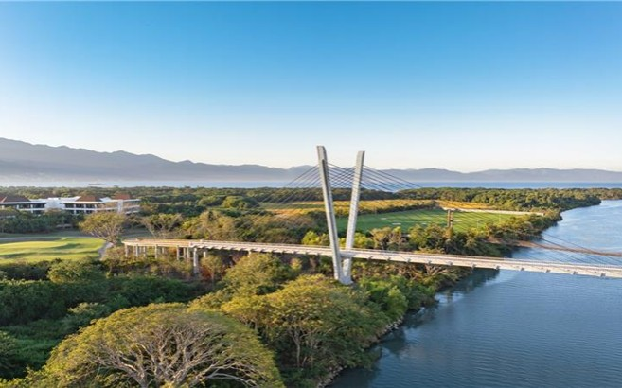
Cable-Stayed Bridge, Nayarit, Mexico

 |  | Stock Listing Information |  | Investor Relations
 |  | NYSE (ADS) |  | In the United States:
 |  | Ticker: CX |  | + 1 877 7CX NYSE
 |  | Mexican Stock Exchange (CPO) |  | In Mexico:
 |  | Ticker: CEMEX.CPO |  | + 52 (81) 8888 4327
 |  | Ratio of CEMEXCPO to CX = 10:1 |  | E-Mail: ir@cemex.com


Operating and financial highlights

 |  | January - September |  |  |  |  |  |  |  |  |  |  |  |  |  |  |  | Third Quarter
 |  | 2026 |  |  |  | 2025 |  |  |  | % var |  |  |  | l-t-l  % var |  |  |  | 2026 |  |  |  | 2025 |  |  |  | % var |  |  |  | l-t-l  % var
Consolidated volumes
Domestic gray cement |  |  | 32,984 |  |  |  | 32,456 |  |  |  | 2 | % |  |  |  |  |  |  | 11,492 |  |  |  | 11,145 |  |  |  | 3 | %
Ready-mix |  |  | 31,989 |  |  |  | 32,506 |  |  |  | (2 | %) |  |  |  |  |  |  | 11,043 |  |  |  | 11,314 |  |  |  | (2 | %)
Aggregates |  |  | 97,319 |  |  |  | 98,650 |  |  |  | (1 | %) |  |  |  |  |  |  | 34,179 |  |  |  | 35,084 |  |  |  | (3 | %)
Sales |  |  | 13,203 |  |  |  | 11,952 |  |  |  | 10 | % |  |  | 5 | % |  |  | 4,590 |  |  |  | 4,245 |  |  |  | 8 | % |  |  | 5 | %
Gross profit |  |  | 4,567 |  |  |  | 3,948 |  |  |  | 16 | % |  |  | 9 | % |  |  | 1,628 |  |  |  | 1,426 |  |  |  | 14 | % |  |  | 10 | %
as % of Sales |  |  | 34.6 | % |  |  | 33.0 | % |  |  | 1.6 | pp |  |  |  |  |  |  | 35.5 | % |  |  | 33.6 | % |  |  | 1.9 | pp
Operating earnings before other income and expenses, net |  |  | 1,785 |  |  |  | 1,332 |  |  |  | 34 | % |  |  | 26 | % |  |  | 652 |  |  |  | 547 |  |  |  | 19 | % |  |  | 15 | %
as % of Sales |  |  | 13.5 | % |  |  | 11.1 | % |  |  | 2.4 | pp |  |  |  |  |  |  | 14.2 | % |  |  | 12.9 | % |  |  | 1.3 | pp
SG&A expenses as a % of Sales |  |  | 8.8 | % |  |  | 9.6 | % |  |  | (0.8 | pp) |  |  |  |  |  |  | 8.1 | % |  |  | 8.7 | % |  |  | (0.6 | pp)
Controlling interest net income (loss) |  |  | 982 |  |  |  | 1,316 |  |  |  | (25 | %) |  |  |  |  |  |  | 407 |  |  |  | 264 |  |  |  | 55 | %
Operating EBITDA |  |  | 2,802 |  |  |  | 2,299 |  |  |  | 22 | % |  |  | 16 | % |  |  | 990 |  |  |  | 882 |  |  |  | 12 | % |  |  | 9 | %
as % of Sales |  |  | 21.2 | % |  |  | 19.2 | % |  |  | 2.0 | pp |  |  |  |  |  |  | 21.6 | % |  |  | 20.8 | % |  |  | 0.8 | pp
Free cash flow from operations |  |  | 1,389 |  |  |  | 473 |  |  |  | 194 | % |  |  |  |  |  |  | 723 |  |  |  | 540 |  |  |  | 34 | %
Total debt |  |  | 6,075 |  |  |  | 6,789 |  |  |  | (11 | %) |  |  |  |  |  |  | 6,075 |  |  |  | 6,789 |  |  |  | (11 | %)
Earnings (loss) of continuing operations per ADS |  |  | 0.68 |  |  |  | 0.47 |  |  |  | 43 | % |  |  |  |  |  |  | 0.28 |  |  |  | 0.16 |  |  |  | 76 | %
Fully diluted earnings (loss) of continuing operations per ADS |  |  | 0.67 |  |  |  | 0.47 |  |  |  | 44 | % |  |  |  |  |  |  | 0.28 |  |  |  | 0.16 |  |  |  | 77 | %
Average diluted ADSs outstanding (1) (2) |  |  | 1,460 |  |  |  | 1,470 |  |  |  | (1 | %) |  |  |  |  |  |  | 1,458 |  |  |  | 1,471 |  |  |  | (1 | %)
Average ADSs outstanding (1) |  |  | 1,443 |  |  |  | 1,448 |  |  |  | (0 | %) |  |  |  |  |  |  | 1,441 |  |  |  | 1,449 |  |  |  | (1 | %)
Employees |  |  | 38,023 |  |  |  | 40,244 |  |  |  | (6 | %) |  |  |  |  |  |  | 38,023 |  |  |  | 40,244 |  |  |  | (6 | %)
Cement and aggregates volumes in thousands of metric tons. Ready-mix volumes in thousands of cubic meters. In millions of U.S. dollars, except volumes, percentages, employees, and per-ADS amounts. Average ADSs outstanding are presented in millions.

(1) | Average ADSs outstanding equals the total number of Series A shares and Series B shares outstanding as if they were all held in ADS form.
(2) | The calculation of Average diluted ADSs outstanding also includes the restricted ADSs allocated to eligible employees as variable compensation.

Consolidated Net Sales reached US$4.6 billion in 3Q26, an 8% increase from 3Q25, supported by higher consolidated prices and improving gray cement volume trends in most markets.
Cost of sales, as a percentage of Net Sales, decreased by 1.9pp to 64.5% in 3Q26 and by 1.6pp to 65.4% on a year-to-date basis, compared with the corresponding periods last year, driven by operational efficiencies under Project Cutting Edge.
Operating expenses, as a percentage of Net Sales, increased by 0.6pp to 21.3% in 3Q26 and decreased by 0.8pp to 21.1% on a year-to-date basis, compared with the corresponding periods last year. The year-to-date improvement was driven by savings under Project Cutting Edge.
Operating EBITDA reached US$990 million in 3Q26, increasing 12% from 3Q25, reflecting the combined benefits of our transformation, higher pricing, growing gray cement volumes, and favorable FX movements. This marks the fifth consecutive quarter with double-digit Operating EBITDA growth.
Operating EBITDA margin in 3Q26 increased 0.8pp year-over-year to 21.6%. Expansion is largely explained by pricing increases, lower energy prices in our cement operations, and improved profitability in our Urbanization Solutions business.
Controlling interest net income reached US$407 million in 3Q26, a 55% increase year-over-year driven mainly by higher Operating earnings.

2026 Third Quarter Results |  | Page 2

Operating results

Mexico

 |  | January - September |  |  |  |  |  |  |  |  |  |  |  |  |  |  |  | Third Quarter
 |  | 2026 |  |  |  | 2025 |  |  |  | % var |  |  |  | l-t-l % var |  |  |  | 2026 |  |  |  | 2025 |  |  |  | % var |  |  |  | l-t-l % var
Sales |  |  | 3,866 |  |  |  | 3,158 |  |  |  | 22 | % |  |  | 10 | % |  |  | 1,299 |  |  |  | 1,117 |  |  |  | 16 | % |  |  | 9 | %
Operating EBITDA |  |  | 1,425 |  |  |  | 1,025 |  |  |  | 39 | % |  |  | 24 | % |  |  | 480 |  |  |  | 369 |  |  |  | 30 | % |  |  | 22 | %
Operating EBITDA margin |  |  | 36.9 | % |  |  | 32.4 | % |  |  | 4.5 | pp |  |  |  |  |  |  | 37.0 | % |  |  | 33.1 | % |  |  | 3.9 | pp
In millions of U.S. dollars; except percentages.

 |  | Domestic gray cement |  |  |  |  |  |  |  | Ready-mix |  |  |  |  |  |  |  | Aggregates
Year-over-year percentage variation |  | January -  September |  |  |  | Third Quarter |  |  |  | January -  September |  |  |  | Third Quarter |  |  |  | January -  September |  |  |  | Third Quarter
Volume |  |  | 7 | % |  |  | 7 | % |  |  | (3 | %) |  |  | (2 | %) |  |  | 2 | % |  |  | (2 | %)
Price (USD) |  |  | 17 | % |  |  | 12 | % |  |  | 15 | % |  |  | 11 | % |  |  | 16 | % |  |  | 11 | %
Price (local currency) |  |  | 6 | % |  |  | 5 | % |  |  | 3 | % |  |  | 4 | % |  |  | 4 | % |  |  | 4 | %
All price variations are based on FOB prices. Price (local currency) for EMEA, Europe, MEA, and SCAC calculated on a volume-weighted-average basis at constant foreign-exchange rates.
Mexico delivered another strong quarter supported by growing cement demand and cost efficiencies, leading to a double-digit increase in Operating EBITDA year-over-year for the quarter.
Sequentially, cement pricing remained stable after adjusting for mix effect, while ready-mix prices increased 2%.
Year-over-year cement volume growth was supported by a healthy residential sector and government-backed social programs, including housing and Rural Roads. Industry demand is expected to remain constructive, reflecting higher infrastructure spending and continued momentum in residential construction in 2027. In ready-mix, the orderbook continues to expand sequentially, especially on infrastructure projects.
United States

 |  | January - September |  |  |  |  |  |  |  |  |  |  |  |  |  |  |  | Third Quarter
 |  | 2026 |  |  |  | 2025 |  |  |  | % var |  |  |  | l-t-l % var |  |  |  | 2026 |  |  |  | 2025 |  |  |  | % var |  |  |  | l-t-l % var
Sales |  |  | 3,884 |  |  |  | 3,806 |  |  |  | 2 | % |  |  | 2 | % |  |  | 1,373 |  |  |  | 1,310 |  |  |  | 5 | % |  |  | 5 | %
Operating EBITDA |  |  | 697 |  |  |  | 738 |  |  |  | (5 | %) |  |  | (5 | %) |  |  | 259 |  |  |  | 269 |  |  |  | (4 | %) |  |  | (4 | %)
Operating EBITDA margin |  |  | 18.0 | % |  |  | 19.4 | % |  |  | (1.4 | pp) |  |  |  |  |  |  | 18.9 | % |  |  | 20.6 | % |  |  | (1.7 | pp)
In millions of U.S. dollars; except percentages.

 |  | Domestic gray cement |  |  |  |  |  |  |  | Ready-mix |  |  |  |  |  |  |  | Aggregates
Year-over-year percentage variation |  | January -  September |  |  |  | Third Quarter |  |  |  | January -  September |  |  |  | Third Quarter |  |  |  | January -  September |  |  |  | Third Quarter
Volume |  |  | 1 | % |  |  | 4 | % |  |  | (0 | %) |  |  | (1 | %) |  |  | 5 | % |  |  | 4 | %
Price (USD) |  |  | (3 | %) |  |  | (4 | %) |  |  | (0 | %) |  |  | 1 | % |  |  | 1 | % |  |  | (1 | %)
Price (local currency) |  |  | (3 | %) |  |  | (4 | %) |  |  | (0 | %) |  |  | 1 | % |  |  | 1 | % |  |  | (1 | %)
All price variations are based on FOB prices. Price (local currency) for EMEA, Europe, MEA, and SCAC calculated on a volume-weighted-average basis at constant foreign-exchange rates.
The United States posted positive volume performance with cement and aggregates increasing 4% during the quarter. Growth was mainly driven by favorable dynamics across most of our markets as well as the contribution from our new mortars platform in the U.S., Omega. Operating EBITDA and Operating EBITDA margin in the quarter were impacted by an unplanned outage, higher raw material cost inflation in ready-mix and cement, and lower cement prices.
Compared to 4Q25, ready-mix and aggregates prices are up mid-single digits, with some erosion in cement prices in select markets.
Demand continues to be led primarily by infrastructure, while industrial-sector demand, particularly related to the AI ecosystem and energy sector, continues to grow. Residential construction remains challenged by affordability constraints and elevated housing inventories.

2026 Third Quarter Results |  | Page 3

Operating results

Europe, Middle East and Africa

 |  | January - September |  |  |  |  |  |  |  |  |  |  |  |  |  |  |  | Third Quarter
 |  | 2026 |  |  |  | 2025 |  |  |  | % var |  |  |  | l-t-l % var |  |  |  | 2026 |  |  |  | 2025 |  |  |  | % var |  |  |  | l-t-l % var
Sales |  |  | 4,115 |  |  |  | 3,790 |  |  |  | 9 | % |  |  | 4 | % |  |  | 1,435 |  |  |  | 1,379 |  |  |  | 4 | % |  |  | 3 | %
Operating EBITDA |  |  | 702 |  |  |  | 593 |  |  |  | 18 | % |  |  | 15 | % |  |  | 257 |  |  |  | 247 |  |  |  | 4 | % |  |  | 4 | %
Operating EBITDA margin |  |  | 17.0 | % |  |  | 15.7 | % |  |  | 1.3 | pp |  |  |  |  |  |  | 17.9 | % |  |  | 17.9 | % |  |  | 0.0 | pp
In millions of U.S. dollars; except percentages.

 |  | Domestic gray cement |  |  |  |  |  |  |  | Ready-mix |  |  |  |  |  |  |  | Aggregates
Year-over-year percentage variation |  | January -  September |  |  |  | Third Quarter |  |  |  | January -  September |  |  |  | Third Quarter |  |  |  | January -  September |  |  |  | Third Quarter
Volume |  |  | (3 | %) |  |  | (1 | %) |  |  | (1 | %) |  |  | (3 | %) |  |  | (6 | %) |  |  | (8 | %)
Price (USD) |  |  | 3 | % |  |  | (3 | %) |  |  | 11 | % |  |  | 8 | % |  |  | 10 | % |  |  | 7 | %
Price (local currency) |  |  | 1 | % |  |  | (1 | %) |  |  | 4 | % |  |  | 5 | % |  |  | 5 | % |  |  | 5 | %
All price variations are based on FOB prices. Price (local currency) for EMEA, Europe, MEA, and SCAC calculated on a volume-weighted-average basis at constant foreign-exchange rates.
The EMEA region delivered favorable results, with Operating EBITDA growth distributed across both subregions, supported by strong pricing and efficiencies from Project Cutting Edge, which partially mitigated rising energy costs in the region.
Sequential pricing was broadly stable in Europe across our three products. Importantly, prices are up low to mid-single digits on a cumulative basis since 4Q25, reflecting successful first-half pricing increases in markets affected by the introduction of the Carbon Border Adjustment Mechanism (CBAM) this year. Across Europe, fuel surcharges and price increases covering the majority of our ready-mix volumes are helping mitigate higher diesel costs.
In Europe, Germany posted cement volume growth for the first time this year and, together with Spain, helped offset softer volumes elsewhere amid persistent heatwaves, project delays, and a fragile recovery in construction activity across several markets.
For Middle East and Africa, double-digit cement volume growth was driven by a demand recovery in Egypt, while our operations in Israel and the UAE remained resilient amid geopolitical tensions.

2026 Third Quarter Results |  | Page 4

Operating results

South, Central America and the Caribbean

 |  | January - September |  |  |  |  |  |  |  |  |  |  |  |  |  |  |  | Third Quarter
 |  | 2026 |  |  |  | 2025 |  |  |  | % var |  |  |  | l-t-l % var |  |  |  | 2026 |  |  |  | 2025 |  |  |  | % var |  |  |  | l-t-l % var
Sales |  |  | 935 |  |  |  | 864 |  |  |  | 8 | % |  |  | (1 | %) |  |  | 333 |  |  |  | 297 |  |  |  | 12 | % |  |  | (0 | %)
Operating EBITDA |  |  | 195 |  |  |  | 170 |  |  |  | 15 | % |  |  | 6 | % |  |  | 62 |  |  |  | 65 |  |  |  | (5 | %) |  |  | (14 | %)
Operating EBITDA margin |  |  | 20.8 | % |  |  | 19.7 | % |  |  | 1.1 | pp |  |  |  |  |  |  | 18.6 | % |  |  | 21.9 | % |  |  | (3.3 | pp)
In millions of U.S. dollars; except percentages.

 |  | Domestic gray cement |  |  |  |  |  |  |  | Ready-mix |  |  |  |  |  |  |  | Aggregates
Year-over-year percentage variation |  | January -  September |  |  |  | Third Quarter |  |  |  | January -  September |  |  |  | Third Quarter |  |  |  | January -  September |  |  |  | Third Quarter
Volume |  |  | 2 | % |  |  | 3 | % |  |  | (6 | %) |  |  | (2 | %) |  |  | (25 | %) |  |  | (19 | %)
Price (USD) |  |  | 7 | % |  |  | 9 | % |  |  | 16 | % |  |  | 22 | % |  |  | 19 | % |  |  | 30 | %
Price (local currency) |  |  | 0 | % |  |  | (0 | %) |  |  | (1 | %) |  |  | (2 | %) |  |  | 1 | % |  |  | 4 | %
All price variations are based on FOB prices. Price (local currency) for EMEA, Europe, MEA, and SCAC calculated on a volume-weighted-average basis at constant foreign-exchange rates.
In South, Central America and the Caribbean, our results were impacted by higher cement purchases in Jamaica, reflecting annual maintenance works and stronger-than-expected demand, along with higher energy costs in the region.
Cement demand in the region remained solid, supported by robust performance in Colombia and Jamaica, with the informal sector driving activity in both markets. In Jamaica, demand also benefited from increased reconstruction activity related to last year’s Hurricane Melissa and continued investment in tourism-related projects.
We remain optimistic on the fundamentals of our portfolio in the region, supported by resilient informal construction.

2026 Third Quarter Results |  | Page 5

Operating results

Operating EBITDA and Free cash flow from operations

 |  | January - September |  |  |  |  |  |  |  |  |  |  |  | Third Quarter
 |  | 2026 |  |  |  | 2025 |  |  |  | % var |  |  |  | 2026 |  |  |  | 2025 |  |  |  | % var
Operating earnings before other income and expenses, net |  |  | 1,785 |  |  |  | 1,332 |  |  |  | 34 | % |  |  | 652 |  |  |  | 547 |  |  |  | 19 | %
Depreciation and amortization of assets |  |  | 1,017 |  |  |  | 967 |  |  |  |  |  |  |  | 338 |  |  |  | 335
Operating EBITDA |  |  | 2,802 |  |  |  | 2,299 |  |  |  | 22 | % |  |  | 990 |  |  |  | 882 |  |  |  | 12 | %
Net Interest Paid |  |  | (226 | ) |  |  | (314 | ) |  |  |  |  |  |  | (69 | ) |  |  | (104 | )
Maintenance capital expenditures & lease payments (1) |  |  | (495 | ) |  |  | (605 | ) |  |  |  |  |  |  | (183 | ) |  |  | (224 | )
Change in working capital |  |  | (505 | ) |  |  | (545 | ) |  |  |  |  |  |  | (3 | ) |  |  | 132
Net Taxes Paid |  |  | (234 | ) |  |  | (223 | ) |  |  |  |  |  |  | (90 | ) |  |  | (87 | )
Other cash expenditures |  |  | (112 | ) |  |  | (219 | ) |  |  |  |  |  |  | (21 | ) |  |  | (67 | )
Proceeds from sales of fixed assets |  |  | 159 |  |  |  | 88 |  |  |  |  |  |  |  | 99 |  |  |  | 8
Free Cash Flows from discontinued operations |  |  | — |  |  |  | (8 | ) |  |  |  |  |  |  | — |  |  |  | (2 | )
Free cash flow from operations |  |  | 1,389 |  |  |  | 473 |  |  |  | 194 | % |  |  | 723 |  |  |  | 540 |  |  |  | 34 | %
In millions of U.S. dollars; except percentages.

(1) | Including lease payments of US$64 million in 3Q26 and US$70 million in 3Q25.
Net debt variation

 |  | YTD variation |  |  |  |  |  |  |  | Quarterly variation
Net debt |  |  | 4Q25: |  |  |  | 4,958 |  |  |  | 2Q26: |  |  |  | 6,225
Free cash flow from operations (effect on Net debt) |  |  |  |  |  |  | (1,389 | ) |  |  |  |  |  |  | (723 | )
Growth capital expenditures |  |  |  |  |  |  | 208 |  |  |  |  |  |  |  | 52
Acquisitions and divestments |  |  |  |  |  |  | 281 |  |  |  |  |  |  |  | 22
Investments in intangible assets |  |  |  |  |  |  | 100 |  |  |  |  |  |  |  | 30
Coupons on subordinated notes |  |  |  |  |  |  | 113 |  |  |  |  |  |  |  | 36
Dividends |  |  |  |  |  |  | 120 |  |  |  |  |  |  |  | 44
Share buybacks |  |  |  |  |  |  | 100 |  |  |  |  |  |  |  | —
Redemption of 5.125% subordinated notes |  |  |  |  |  |  | 1,000 |  |  |  |  |  |  |  | —
Others, net (1) |  |  |  |  |  |  | (67 | ) |  |  |  |  |  |  | (263 | )
Net debt variation |  |  |  |  |  |  | 466 |  |  |  |  |  |  |  | (802 | )
Net debt |  |  | 3Q26: |  |  |  | 5,423 |  |  |  | 3Q26: |  |  |  | 5,423
In millions of U.S. dollars; except percentages.

(1) | “Others, net” primarily reflects the EUR 200 million grant received from the Spanish government in 3Q26 for a proposed carbon capture project. Year-to-date, this benefit was partially offset by pension plan payments and a reduction in the balance of securitization programs.
Information on debt
 |  | Third Quarter |  |  |  |  |  |  |  |  |  |  |  | Second  Quarter
 |  | 2026 |  |  |  | 2025 |  |  |  | % var |  |  |  | 2026
Total debt (1) |  |  | 6,075 |  |  |  | 6,789 |  |  |  | (11 | %) |  |  | 6,879
Short-term |  |  | 7 | % |  |  | 11 | % |  |  |  |  |  |  | 6 | %
Long-term |  |  | 93 | % |  |  | 89 | % |  |  |  |  |  |  | 94 | %
Cash and cash equivalents |  |  | 652 |  |  |  | 1,198 |  |  |  | (46 | %) |  |  | 654
Net debt |  |  | 5,423 |  |  |  | 5,592 |  |  |  | (3 | %) |  |  | 6,225
Leverage ratio (2) |  |  | 1.80 |  |  |  | 2.52 |  |  |  |  |  |  |  | 2.08

 |  | Third Quarter
CURRENCY DENOMINATION (3) |  | 2026 |  |  |  | 2025
U.S. dollar |  |  | 79 | % |  |  | 68 | %
Euro |  |  | 16 | % |  |  | 21 | %
Mexican peso |  |  | 2 | % |  |  | 7 | %
Other |  |  | 3 | % |  |  | 3 | %
INTEREST RATE (3)
Fixed |  |  | 87 | % |  |  | 67 | %
Variable |  |  | 13 | % |  |  | 33 | %

In millions of U.S. dollars; except percentages and ratios.

(1) | Includes leases, in accordance with International Financial Reporting Standards (IFRS).
(2) | Calculated based on Net debt plus subordinated notes. Although subordinated notes are not considered debt, they are included in this calculation for ease of review by financial analysts.
(3) | Includes the effect of our interest rate and cross-currency derivatives, as applicable.

2026 Third Quarter Results |  | Page 6

Operating results

Consolidated Statement of Operations & Statement of Financial Position
Cemex, S.A.B. de C.V. and Subsidiaries
In thousands of U.S. dollars, except per ADS amounts

 |  | January - September |  |  |  |  |  |  |  |  |  |  |  |  |  |  |  | Third Quarter
STATEMENT OF OPERATIONS |  | 2026 |  |  |  | 2025 |  |  |  | % var |  |  |  | l-t-l  % var |  |  |  | 2026 |  |  |  | 2025 |  |  |  | % var |  |  |  | l-t-l  % var
Sales |  |  | 13,202,902 |  |  |  | 11,952,175 |  |  |  | 10 | % |  |  | 5 | % |  |  | 4,590,392 |  |  |  | 4,245,421 |  |  |  | 8 | % |  |  | 5 | %
Cost of sales |  |  | (8,636,286 | ) |  |  | (8,004,350 | ) |  |  | (8 | %) |  |  |  |  |  |  | (2,961,978 | ) |  |  | (2,819,782 | ) |  |  | (5 | %)
Gross profit |  |  | 4,566,616 |  |  |  | 3,947,825 |  |  |  | 16 | % |  |  | 9 | % |  |  | 1,628,414 |  |  |  | 1,425,639 |  |  |  | 14 | % |  |  | 10 | %
Operating expenses |  |  | (2,781,300 | ) |  |  | (2,615,743 | ) |  |  | (6 | %) |  |  |  |  |  |  | (976,430 | ) |  |  | (878,310 | ) |  |  | (11 | %)
Operating earnings before other income and expenses, net |  |  | 1,785,315 |  |  |  | 1,332,081 |  |  |  | 34 | % |  |  | 26 | % |  |  | 651,984 |  |  |  | 547,329 |  |  |  | 19 | % |  |  | 15 | %
Other expenses, net |  |  | (66,779 | ) |  |  | (208,634 | ) |  |  | 68 | % |  |  |  |  |  |  | 25,883 |  |  |  | (95,090 | ) |  |  | N/A
Operating earnings |  |  | 1,718,536 |  |  |  | 1,123,447 |  |  |  | 53 | % |  |  |  |  |  |  | 677,867 |  |  |  | 452,239 |  |  |  | 50 | %
Financial expense |  |  | (307,361 | ) |  |  | (345,721 | ) |  |  | 11 | % |  |  |  |  |  |  | (102,913 | ) |  |  | (110,148 | ) |  |  | 7 | %
Other financial income (expense), net |  |  | (55,641 | ) |  |  | 138,086 |  |  |  | N/A |  |  |  |  |  |  |  | (14,795 | ) |  |  | (11,938 | ) |  |  | (24 | %)
Financial income |  |  | 37,281 |  |  |  | 31,342 |  |  |  | 19 | % |  |  |  |  |  |  | 9,359 |  |  |  | 12,196 |  |  |  | (23 | %)
Results from financial instruments, net |  |  | 11,886 |  |  |  | (40,066 | ) |  |  | N/A |  |  |  |  |  |  |  | 8,791 |  |  |  | (7,133 | ) |  |  | N/A
Foreign exchange results |  |  | (28,599 | ) |  |  | 213,902 |  |  |  | N/A |  |  |  |  |  |  |  | (7,419 | ) |  |  | 5,968 |  |  |  | N/A
Effects on net present value on assets and liabilities and others, net |  |  | (76,210 | ) |  |  | (67,091 | ) |  |  | (14 | %) |  |  |  |  |  |  | (25,526 | ) |  |  | (22,969 | ) |  |  | (11 | %)
Equity in gain (loss) of associates |  |  | 45,554 |  |  |  | 55,883 |  |  |  | (18 | %) |  |  |  |  |  |  | 20,186 |  |  |  | 30,624 |  |  |  | (34 | %)
Income (loss) before income tax |  |  | 1,401,088 |  |  |  | 971,696 |  |  |  | 44 | % |  |  |  |  |  |  | 580,345 |  |  |  | 360,777 |  |  |  | 61 | %
Income tax |  |  | (404,578 | ) |  |  | (272,535 | ) |  |  | (48 | %) |  |  |  |  |  |  | (170,920 | ) |  |  | (120,868 | ) |  |  | (41 | %)
Profit (loss) of continuing operations |  |  | 996,510 |  |  |  | 699,161 |  |  |  | 43 | % |  |  |  |  |  |  | 409,425 |  |  |  | 239,909 |  |  |  | 71 | %
Discontinued operations |  |  | 4,005 |  |  |  | 631,711 |  |  |  | (99 | %) |  |  |  |  |  |  | 1,516 |  |  |  | 32,140 |  |  |  | (95 | %)
Consolidated net income (loss) |  |  | 1,000,515 |  |  |  | 1,330,872 |  |  |  | (25 | %) |  |  |  |  |  |  | 410,941 |  |  |  | 272,049 |  |  |  | 51 | %
Non-controlling interest net income (loss) |  |  | 18,769 |  |  |  | 15,196 |  |  |  | 24 | % |  |  |  |  |  |  | 3,490 |  |  |  | 8,349 |  |  |  | (58 | %)
Controlling interest net income (loss) |  |  | 981,746 |  |  |  | 1,315,676 |  |  |  | (25 | %) |  |  |  |  |  |  | 407,451 |  |  |  | 263,699 |  |  |  | 55 | %
Operating EBITDA |  |  | 2,802,168 |  |  |  | 2,299,039 |  |  |  | 22 | % |  |  | 16 | % |  |  | 990,206 |  |  |  | 882,264 |  |  |  | 12 | % |  |  | 9 | %
Earnings (loss) of continuing operations per ADS |  |  | 0.68 |  |  |  | 0.47 |  |  |  | 43 | % |  |  |  |  |  |  | 0.28 |  |  |  | 0.16 |  |  |  | 76 | %

 |  | As of September 30
STATEMENT OF FINANCIAL POSITION |  | 2026 |  |  |  | 2025 |  |  |  | % var
Total assets |  |  | 27,968,733 |  |  |  | 29,007,657 |  |  |  | (4 | %)
Cash and cash equivalents |  |  | 651,975 |  |  |  | 1,197,717 |  |  |  | (46 | %)
Trade receivables less allowance for doubtful accounts |  |  | 2,040,120 |  |  |  | 1,960,041 |  |  |  | 4 | %
Other accounts receivable |  |  | 959,085 |  |  |  | 781,700 |  |  |  | 23 | %
Inventories, net |  |  | 1,498,934 |  |  |  | 1,559,293 |  |  |  | (4 | %)
Assets held for sale |  |  | 753,970 |  |  |  | 306,185 |  |  |  | 146 | %
Other current assets |  |  | 126,069 |  |  |  | 151,585 |  |  |  | (17 | %)
Current assets |  |  | 6,030,153 |  |  |  | 5,956,521 |  |  |  | 1 | %
Property, machinery, and equipment, net |  |  | 11,507,560 |  |  |  | 11,908,751 |  |  |  | (3 | %)
Other assets |  |  | 10,431,021 |  |  |  | 11,142,385 |  |  |  | (6 | %)
Total liabilities |  |  | 14,762,425 |  |  |  | 15,090,221 |  |  |  | (2 | %)
Current liabilities |  |  | 6,372,500 |  |  |  | 6,526,442 |  |  |  | (2 | %)
Long-term liabilities |  |  | 4,897,320 |  |  |  | 5,142,095 |  |  |  | (5 | %)
Other liabilities |  |  | 3,492,605 |  |  |  | 3,421,685 |  |  |  | 2 | %
Total stockholders’ equity |  |  | 13,206,308 |  |  |  | 13,917,436 |  |  |  | (5 | %)
Common stock and additional paid-in capital |  |  | 7,699,108 |  |  |  | 7,699,108 |  |  |  | 0 | %
Other equity reserves |  |  | (2,651,337 | ) |  |  | (2,502,420 | ) |  |  | (6 | %)
Subordinated notes |  |  | 974,000 |  |  |  | 1,974,000 |  |  |  | (51 | %)
Retained earnings |  |  | 6,878,780 |  |  |  | 6,432,432 |  |  |  | 7 | %
Non-controlling interest |  |  | 305,757 |  |  |  | 314,316 |  |  |  | (3 | %)

2026 Third Quarter Results |  | Page 7

Operating results

Operating summary per country
In thousands of U.S. dollars

 |  | January - September |  |  |  |  |  |  |  |  |  |  |  |  |  |  |  | Third Quarter
SALES |  | 2026 |  |  |  | 2025 |  |  |  | % var |  |  |  | l-t-l  % var |  |  |  | 2026 |  |  |  | 2025 |  |  |  | % var |  |  |  | l-t-l  % var
Mexico |  |  | 3,866,185 |  |  |  | 3,158,145 |  |  |  | 22 | % |  |  | 10 | % |  |  | 1,299,267 |  |  |  | 1,117,220 |  |  |  | 16 | % |  |  | 9 | %
U.S.A. |  |  | 3,883,535 |  |  |  | 3,806,159 |  |  |  | 2 | % |  |  | 2 | % |  |  | 1,372,811 |  |  |  | 1,309,885 |  |  |  | 5 | % |  |  | 5 | %
Europe, Middle East and Africa |  |  | 4,115,269 |  |  |  | 3,789,670 |  |  |  | 9 | % |  |  | 4 | % |  |  | 1,434,717 |  |  |  | 1,378,733 |  |  |  | 4 | % |  |  | 3 | %
Europe |  |  | 2,950,114 |  |  |  | 2,849,253 |  |  |  | 4 | % |  |  | 1 | % |  |  | 1,022,235 |  |  |  | 1,026,428 |  |  |  | (0 | %) |  |  | 1 | %
Middle East and Africa |  |  | 1,165,155 |  |  |  | 940,417 |  |  |  | 24 | % |  |  | 13 | % |  |  | 412,482 |  |  |  | 352,306 |  |  |  | 17 | % |  |  | 11 | %
South, Central America and the Caribbean |  |  | 935,300 |  |  |  | 863,555 |  |  |  | 8 | % |  |  | (1 | %) |  |  | 333,152 |  |  |  | 297,492 |  |  |  | 12 | % |  |  | (0 | %)
Others and intercompany eliminations |  |  | 402,613 |  |  |  | 334,645 |  |  |  | 20 | % |  |  | 23 | % |  |  | 150,446 |  |  |  | 142,090 |  |  |  | 6 | % |  |  | 7 | %
TOTAL |  |  | 13,202,902 |  |  |  | 11,952,175 |  |  |  | 10 | % |  |  | 5 | % |  |  | 4,590,392 |  |  |  | 4,245,421 |  |  |  | 8 | % |  |  | 5 | %
GROSS PROFIT
Mexico |  |  | 2,062,236 |  |  |  | 1,587,411 |  |  |  | 30 | % |  |  | 17 | % |  |  | 688,612 |  |  |  | 558,833 |  |  |  | 23 | % |  |  | 16 | %
U.S.A. |  |  | 1,052,552 |  |  |  | 1,079,590 |  |  |  | (3 | %) |  |  | (3 | %) |  |  | 395,123 |  |  |  | 385,135 |  |  |  | 3 | % |  |  | 3 | %
Europe, Middle East and Africa |  |  | 1,125,364 |  |  |  | 1,006,311 |  |  |  | 12 | % |  |  | 9 | % |  |  | 408,460 |  |  |  | 389,920 |  |  |  | 5 | % |  |  | 4 | %
Europe |  |  | 875,638 |  |  |  | 801,331 |  |  |  | 9 | % |  |  | 7 | % |  |  | 317,531 |  |  |  | 311,878 |  |  |  | 2 | % |  |  | 3 | %
Middle East and Africa |  |  | 249,726 |  |  |  | 204,980 |  |  |  | 22 | % |  |  | 14 | % |  |  | 90,928 |  |  |  | 78,042 |  |  |  | 17 | % |  |  | 11 | %
South, Central America and the Caribbean |  |  | 289,367 |  |  |  | 271,232 |  |  |  | 7 | % |  |  | (3 | %) |  |  | 97,477 |  |  |  | 97,936 |  |  |  | (0 | %) |  |  | (17 | %)
Others and intercompany eliminations |  |  | 37,097 |  |  |  | 3,281 |  |  |  | N/A |  |  |  | N/A |  |  |  | 38,743 |  |  |  | (6,185 | ) |  |  | N/A |  |  |  | N/A
TOTAL |  |  | 4,566,616 |  |  |  | 3,947,825 |  |  |  | 16 | % |  |  | 9 | % |  |  | 1,628,414 |  |  |  | 1,425,639 |  |  |  | 14 | % |  |  | 10 | %
OPERATING EARNINGS BEFORE OTHER INCOME AND EXPENSES, NET
Mexico |  |  | 1,255,164 |  |  |  | 867,780 |  |  |  | 45 | % |  |  | 29 | % |  |  | 423,410 |  |  |  | 314,626 |  |  |  | 35 | % |  |  | 26 | %
U.S.A. |  |  | 301,422 |  |  |  | 349,883 |  |  |  | (14 | %) |  |  | (14 | %) |  |  | 125,939 |  |  |  | 137,596 |  |  |  | (8 | %) |  |  | (8 | %)
Europe, Middle East and Africa |  |  | 447,406 |  |  |  | 343,452 |  |  |  | 30 | % |  |  | 28 | % |  |  | 174,981 |  |  |  | 160,587 |  |  |  | 9 | % |  |  | 9 | %
Europe |  |  | 307,401 |  |  |  | 231,059 |  |  |  | 33 | % |  |  | 32 | % |  |  | 125,158 |  |  |  | 116,543 |  |  |  | 7 | % |  |  | 8 | %
Middle East and Africa |  |  | 140,005 |  |  |  | 112,393 |  |  |  | 25 | % |  |  | 19 | % |  |  | 49,822 |  |  |  | 44,044 |  |  |  | 13 | % |  |  | 10 | %
South, Central America and the Caribbean |  |  | 126,483 |  |  |  | 118,217 |  |  |  | 7 | % |  |  | 1 | % |  |  | 38,016 |  |  |  | 45,475 |  |  |  | (16 | %) |  |  | (24 | %)
Others and intercompany eliminations |  |  | (345,159 | ) |  |  | (347,250 | ) |  |  | 1 | % |  |  | 12 | % |  |  | (110,363 | ) |  |  | (110,956 | ) |  |  | 1 | % |  |  | 8 | %
TOTAL |  |  | 1,785,315 |  |  |  | 1,332,081 |  |  |  | 34 | % |  |  | 26 | % |  |  | 651,984 |  |  |  | 547,329 |  |  |  | 19 | % |  |  | 15 | %

2026 Third Quarter Results |  | Page 8

Operating results

Operating summary per country
Operating EBITDA in thousands of U.S. dollars
Operating EBITDA margin as a percentage of sales

 |  | January - September |  |  |  |  |  |  |  |  |  |  |  |  |  |  |  | Third Quarter
OPERATING EBITDA |  | 2026 |  |  |  | 2025 |  |  |  | %  var |  |  |  | l-t-l  % var |  |  |  | 2026 |  |  |  | 2025 |  |  |  | %  var |  |  |  | l-t-l  % var
Mexico |  |  | 1,424,963 |  |  |  | 1,024,509 |  |  |  | 39 | % |  |  | 24 | % |  |  | 480,403 |  |  |  | 369,400 |  |  |  | 30 | % |  |  | 22 | %
U.S.A. |  |  | 697,431 |  |  |  | 737,588 |  |  |  | (5 | %) |  |  | (5 | %) |  |  | 259,307 |  |  |  | 269,307 |  |  |  | (4 | %) |  |  | (4 | %)
Europe, Middle East and Africa |  |  | 701,604 |  |  |  | 593,119 |  |  |  | 18 | % |  |  | 15 | % |  |  | 257,318 |  |  |  | 247,059 |  |  |  | 4 | % |  |  | 4 | %
Europe |  |  | 503,288 |  |  |  | 430,497 |  |  |  | 17 | % |  |  | 15 | % |  |  | 189,110 |  |  |  | 183,908 |  |  |  | 3 | % |  |  | 4 | %
Middle East and Africa |  |  | 198,316 |  |  |  | 162,622 |  |  |  | 22 | % |  |  | 14 | % |  |  | 68,208 |  |  |  | 63,151 |  |  |  | 8 | % |  |  | 3 | %
South, Central America and the Caribbean |  |  | 194,726 |  |  |  | 169,753 |  |  |  | 15 | % |  |  | 6 | % |  |  | 61,970 |  |  |  | 65,033 |  |  |  | (5 | %) |  |  | (14 | %)
Others and intercompany eliminations |  |  | (216,556 | ) |  |  | (225,929 | ) |  |  | 4 | % |  |  | 22 | % |  |  | (68,791 | ) |  |  | (68,534 | ) |  |  | (0 | %) |  |  | 12 | %
TOTAL |  |  | 2,802,168 |  |  |  | 2,299,039 |  |  |  | 22 | % |  |  | 16 | % |  |  | 990,206 |  |  |  | 882,264 |  |  |  | 12 | % |  |  | 9 | %
OPERATING EBITDA MARGIN
Mexico |  |  | 36.9 | % |  |  | 32.4 | % |  |  | 4.5 | pp |  |  |  |  |  |  | 37.0 | % |  |  | 33.1 | % |  |  | 3.9 | pp
U.S.A. |  |  | 18.0 | % |  |  | 19.4 | % |  |  | (1.4 | pp) |  |  |  |  |  |  | 18.9 | % |  |  | 20.6 | % |  |  | (1.7 | pp)
Europe, Middle East and Africa |  |  | 17.0 | % |  |  | 15.7 | % |  |  | 1.3 | pp |  |  |  |  |  |  | 17.9 | % |  |  | 17.9 | % |  |  | 0.0 | pp
Europe |  |  | 17.1 | % |  |  | 15.1 | % |  |  | 2.0 | pp |  |  |  |  |  |  | 18.5 | % |  |  | 17.9 | % |  |  | 0.6 | pp
Middle East and Africa |  |  | 17.0 | % |  |  | 17.3 | % |  |  | (0.3 | pp) |  |  |  |  |  |  | 16.5 | % |  |  | 17.9 | % |  |  | (1.4 | pp)
South, Central America and the Caribbean |  |  | 20.8 | % |  |  | 19.7 | % |  |  | 1.1 | pp |  |  |  |  |  |  | 18.6 | % |  |  | 21.9 | % |  |  | (3.3 | pp)
TOTAL |  |  | 21.2 | % |  |  | 19.2 | % |  |  | 2.0 | pp |  |  |  |  |  |  | 21.6 | % |  |  | 20.8 | % |  |  | 0.8 | pp

2026 Third Quarter Results |  | Page 9

Operating results

Volume summary
Cement and aggregates: Thousands of metric tons
Ready-mix: Thousands of cubic meters

 |  | January - September |  |  |  |  |  |  |  |  |  |  |  | Third Quarter
 |  | 2026 |  |  |  | 2025 |  |  |  | % var |  |  |  | 2026 |  |  |  | 2025 |  |  |  | % var
Consolidated cement volume (1) |  |  | 38,817 |  |  |  | 39,319 |  |  |  | (1 | %) |  |  | 13,408 |  |  |  | 13,938 |  |  |  | (4 | %)
Consolidated ready-mix volume |  |  | 31,989 |  |  |  | 32,506 |  |  |  | (2 | %) |  |  | 11,043 |  |  |  | 11,314 |  |  |  | (2 | %)
Consolidated aggregates volume (2) |  |  | 97,319 |  |  |  | 98,650 |  |  |  | (1 | %) |  |  | 34,179 |  |  |  | 35,084 |  |  |  | (3 | %)
Per-country volume summary

 |  | January - September |  |  |  | Third Quarter |  |  |  | Third Quarter 2026
DOMESTIC GRAY CEMENT |  | 2026 vs. 2025 |  |  |  | 2026 vs. 2025 |  |  |  | vs. Second Quarter 2026
Mexico |  |  | 7 | % |  |  | 7 | % |  |  | 0 | %
U.S.A. |  |  | 1 | % |  |  | 4 | % |  |  | 3 | %
Europe, Middle East and Africa |  |  | (3 | %) |  |  | (1 | %) |  |  | 0 | %
Europe |  |  | (5 | %) |  |  | (5 | %) |  |  | (3 | %)
Middle East and Africa |  |  | 2 | % |  |  | 12 | % |  |  | 8 | %
South, Central America and the Caribbean |  |  | 2 | % |  |  | 3 | % |  |  | 5 | %

 |  | January - September |  |  |  | Third Quarter |  |  |  | Third Quarter 2026
READY-MIX |  | 2026 vs. 2025 |  |  |  | 2026 vs. 2025 |  |  |  | vs. Second Quarter 2026
Mexico |  |  | (3 | %) |  |  | (2 | %) |  |  | 2 | %
U.S.A. |  |  | (0 | %) |  |  | (1 | %) |  |  | 3 | %
Europe, Middle East and Africa |  |  | (1 | %) |  |  | (3 | %) |  |  | 0 | %
Europe |  |  | (6 | %) |  |  | (7 | %) |  |  | (2 | %)
Middle East and Africa |  |  | 5 | % |  |  | 1 | % |  |  | 4 | %
South, Central America and the Caribbean |  |  | (6 | %) |  |  | (2 | %) |  |  | 10 | %

 |  | January - September |  |  |  | Third Quarter |  |  |  | Third Quarter 2026
AGGREGATES |  | 2026 vs. 2025 |  |  |  | 2026 vs. 2025 |  |  |  | vs. Second Quarter 2026
Mexico |  |  | 2 | % |  |  | (2 | %) |  |  | 1 | %
U.S.A. |  |  | 5 | % |  |  | 4 | % |  |  | 9 | %
Europe, Middle East and Africa |  |  | (6 | %) |  |  | (8 | %) |  |  | (0 | %)
Europe |  |  | (7 | %) |  |  | (8 | %) |  |  | (1 | %)
Middle East and Africa |  |  | (3 | %) |  |  | (7 | %) |  |  | 2 | %
South, Central America and the Caribbean |  |  | (25 | %) |  |  | (19 | %) |  |  | 14 | %

(1) | Consolidated cement volumes include domestic and export volume of gray cement, white cement, special cement, mortar, and clinker.
(2) | Consolidated aggregates volumes include aggregates from our marine business in the United Kingdom.

2026 Third Quarter Results |  | Page 10

Operating results

Price summary
Variation in U.S. dollars

 |  | January - September |  |  |  | Third Quarter |  |  |  | Third Quarter 2026
DOMESTIC GRAY CEMENT |  | 2026 vs. 2025 |  |  |  | 2026 vs. 2025 |  |  |  | vs. Second Quarter 2026
Mexico |  |  | 17 | % |  |  | 12 | % |  |  | (1 | %)
U.S.A. |  |  | (3 | %) |  |  | (4 | %) |  |  | (3 | %)
Europe, Middle East and Africa |  |  | 3 | % |  |  | (3 | %) |  |  | (4 | %)
Europe |  |  | 3 | % |  |  | 0 | % |  |  | (2 | %)
Middle East and Africa |  |  | 8 | % |  |  | (5 | %) |  |  | (2 | %)
South, Central America and the Caribbean |  |  | 7 | % |  |  | 9 | % |  |  | 2 | %

 |  | January - September |  |  |  | Third Quarter |  |  |  | Third Quarter 2026
READY-MIX |  | 2026 vs. 2025 |  |  |  | 2026 vs. 2025 |  |  |  | vs. Second Quarter 2026
Mexico |  |  | 15 | % |  |  | 11 | % |  |  | 2 | %
U.S.A. |  |  | (0 | %) |  |  | 1 | % |  |  | 1 | %
Europe, Middle East and Africa |  |  | 11 | % |  |  | 8 | % |  |  | (2 | %)
Europe |  |  | 5 | % |  |  | 1 | % |  |  | (1 | %)
Middle East and Africa |  |  | 24 | % |  |  | 21 | % |  |  | (3 | %)
South, Central America and the Caribbean |  |  | 16 | % |  |  | 22 | % |  |  | 9 | %

 |  | January - September |  |  |  | Third Quarter |  |  |  | Third Quarter 2026
AGGREGATES |  | 2026 vs. 2025 |  |  |  | 2026 vs. 2025 |  |  |  | vs. Second Quarter 2026
Mexico |  |  | 16 | % |  |  | 11 | % |  |  | (3 | %)
U.S.A. |  |  | 1 | % |  |  | (1 | %) |  |  | (2 | %)
Europe, Middle East and Africa |  |  | 10 | % |  |  | 7 | % |  |  | (3 | %)
Europe |  |  | 7 | % |  |  | 4 | % |  |  | (3 | %)
Middle East and Africa |  |  | 24 | % |  |  | 19 | % |  |  | (4 | %)
South, Central America and the Caribbean |  |  | 19 | % |  |  | 30 | % |  |  | 12 | %
All price variations are based on FOB prices. Price (local currency) for EMEA, Europe, MEA, and SCAC calculated on a volume-weighted-average basis at constant foreign-exchange rates.

2026 Third Quarter Results |  | Page 11

Operating results

Price summary
Variation in Local Currency

 |  | January - September |  |  |  | Third Quarter |  |  |  | Third Quarter 2026
DOMESTIC GRAY CEMENT |  | 2026 vs. 2025 |  |  |  | 2026 vs. 2025 |  |  |  | vs. Second Quarter 2026
Mexico |  |  | 6 | % |  |  | 5 | % |  |  | (1 | %)
U.S.A. |  |  | (3 | %) |  |  | (4 | %) |  |  | (3 | %)
Europe, Middle East and Africa |  |  | 1 | % |  |  | (1 | %) |  |  | (3 | %)
Europe |  |  | 1 | % |  |  | 1 | % |  |  | (1 | %)
Middle East and Africa |  |  | 10 | % |  |  | (0 | %) |  |  | (3 | %)
South, Central America and the Caribbean |  |  | 0 | % |  |  | (0 | %) |  |  | (2 | %)

 |  | January - September |  |  |  | Third Quarter |  |  |  | Third Quarter 2026
READY-MIX |  | 2026 vs. 2025 |  |  |  | 2026 vs. 2025 |  |  |  | vs. Second Quarter 2026
Mexico |  |  | 3 | % |  |  | 4 | % |  |  | 2 | %
U.S.A. |  |  | (0 | %) |  |  | 1 | % |  |  | 1 | %
Europe, Middle East and Africa |  |  | 4 | % |  |  | 5 | % |  |  | (0 | %)
Europe |  |  | 2 | % |  |  | 2 | % |  |  | (0 | %)
Middle East and Africa |  |  | 10 | % |  |  | 12 | % |  |  | 0 | %
South, Central America and the Caribbean |  |  | (1 | %) |  |  | (2 | %) |  |  | (2 | %)

 |  | January - September |  |  |  | Third Quarter |  |  |  | Third Quarter 2026
AGGREGATES |  | 2026 vs. 2025 |  |  |  | 2026 vs. 2025 |  |  |  | vs. Second Quarter 2026
Mexico |  |  | 4 | % |  |  | 4 | % |  |  | (3 | %)
U.S.A. |  |  | 1 | % |  |  | (1 | %) |  |  | (2 | %)
Europe, Middle East and Africa |  |  | 5 | % |  |  | 5 | % |  |  | (2 | %)
Europe |  |  | 4 | % |  |  | 5 | % |  |  | (2 | %)
Middle East and Africa |  |  | 8 | % |  |  | 8 | % |  |  | 0 | %
South, Central America and the Caribbean |  |  | 1 | % |  |  | 4 | % |  |  | 1 | %
All price variations are based on FOB prices. Price (local currency) for EMEA, Europe, MEA, and SCAC calculated on a volume-weighted-average basis at constant foreign-exchange rates.

2026 Third Quarter Results |  | Page 12

Other information

Operating expenses
The following table shows the breakdown of operating expenses for the period presented.

 |  | January - September |  |  |  |  |  |  |  |  |  |  |  | Third Quarter
(Thousands of U.S. dollars) |  | 2026 |  |  |  | 2025 |  |  |  | % var |  |  |  | 2026 |  |  |  | 2025 |  |  |  | % var
General and administrative expenses |  |  | 891,830 |  |  |  | 880,240 |  |  |  | 1 | % |  |  | 281,916 |  |  |  | 283,334 |  |  |  | (1 | %)
Selling expenses |  |  | 268,821 |  |  |  | 269,857 |  |  |  | (0 | %) |  |  | 90,753 |  |  |  | 87,771 |  |  |  | 3 | %
Distribution and logistics expenses |  |  | 1,410,271 |  |  |  | 1,286,289 |  |  |  | 10 | % |  |  | 530,583 |  |  |  | 445,396 |  |  |  | 19 | %
Operating expenses before depreciation |  |  | 2,570,922 |  |  |  | 2,436,386 |  |  |  | 6 | % |  |  | 903,251 |  |  |  | 816,501 |  |  |  | 11 | %
Depreciation in operating expenses |  |  | 210,378 |  |  |  | 179,357 |  |  |  | 17 | % |  |  | 73,179 |  |  |  | 61,809 |  |  |  | 18 | %
Operating expenses |  |  | 2,781,300 |  |  |  | 2,615,743 |  |  |  | 6 | % |  |  | 976,430 |  |  |  | 878,310 |  |  |  | 11 | %

As % of Net Sales
General and administrative expenses |  |  | 6.8 | % |  |  | 7.4 | % |  |  | 6.1 | % |  |  | 6.7 | %
SG&A expenses |  |  | 8.8 | % |  |  | 9.6 | % |  |  | 8.1 | % |  |  | 8.7 | %
Equity-related information
As of December 31, 2025, the number of outstanding CPO-equivalents was 14,508,328,248. See Cemex’s reports furnished to or filed with the U.S. Securities and Exchange Commission for information, if any, regarding repurchases of securities and other developments that may have caused a change in the number of CPO-equivalents outstanding after December 31, 2025. For the three-month period ended March 31, 2026, 78,803,711 CPOs were repurchased by Cemex under its share repurchase program approved at Cemex, S.A.B. de C.V.’s ordinary annual shareholders meeting held on March 25, 2025. On March 26, 2026, Cemex, S.A.B. de C.V.’s ordinary annual shareholders meeting approved a new repurchase program that will be in effect until the next annual shareholders meeting to be held in 2027. No CPOs were repurchased by Cemex under such program from March 26, 2026 to September 30, 2026.
One Cemex ADS represents ten Cemex CPOs. One Cemex CPO represents two Series A shares and one Series B share.
For purposes of this report, outstanding CPO-equivalents equal the total number of Series A and B shares outstanding as if they were all held in CPO form, less CPOs held by Cemex and its subsidiaries, which as of December 31, 2025, were 20,541,277. Starting 2024, employees receive restricted ADRs instead of restricted CPOs. Restricted ADRs allocated to eligible employees as variable compensation are not included in the outstanding CPO-equivalents.
Derivative instruments
The following table shows the notional amount for each type of derivative instrument and the aggregate fair market value for all of Cemex’s derivative instruments as of the last day of each quarter presented.

 |  | Third Quarter |  |  |  |  |  |  |  |  |  |  |  |  |  |  |  | Second Quarter
(Millions of U.S. dollars) |  | 2026 |  |  |  |  |  |  |  | 2025 |  |  |  |  |  |  |  | 2026
 |  | Notional  amount |  |  |  | Fair  value |  |  |  | Notional  amount |  |  |  | Fair  value |  |  |  | Notional  amount |  |  |  | Fair  value
Exchange rate derivatives (1) |  |  | 1,045 |  |  |  | (37 | ) |  |  | 1,313 |  |  |  | (63 | ) |  |  | 1,225 |  |  |  | (80 | )
Interest rate swaps (2) |  |  | 1,723 |  |  |  | (11 | ) |  |  | 1,640 |  |  |  | (26 | ) |  |  | 1,733 |  |  |  | 7
Fuel derivatives (3) |  |  | 203 |  |  |  | 84 |  |  |  | 244 |  |  |  | 7 |  |  |  | 264 |  |  |  | 31
 |  |  | 2,971 |  |  |  | 36 |  |  |  | 3,197 |  |  |  | (82 | ) |  |  | 3,222 |  |  |  | (42 | )

(1) | The exchange rate derivatives are used to manage currency exposures arising from net investments in foreign operations.
(2) | As of September 30, 2026, these instruments are associated with bank loans, including interest rate and exchange rate swap derivatives.
(3) | Cemex’s derivative financial instruments portfolio includes swaps and financial options. These derivative instruments are mainly used to hedge the market price risk of certain fuels associated with certain Cemex operations, such as transportation and production. In addition, there are call spreads on Brent oil and derivatives thereof, designed to mitigate the exposure related to the implicit cost of fuel in distribution expenses.
Under IFRS, companies are required to recognize the fair value of all derivative financial instruments on the balance sheet as financial assets or liabilities, with changes in such fair market values recorded in the income statement, except when transactions are entered into for hedging purposes. In cash-flow hedging cases, changes in the fair market value of the related derivative instruments are recognized temporarily in equity and subsequently reclassified into earnings as the effects of the underlying are recognized in the income statement. Moreover, in transactions related to net investment hedges, changes in fair market value are recorded directly in equity as part of the currency translation effect and are reclassified to the income statement only in the case of disposal of the net investment. As of September 30, 2026, in connection with the derivatives portfolio’s fair market value, Cemex recognized changes in fair market value resulting in a financial asset of US$36 million.

2026 Third Quarter Results |  | Page 13

Other information

Discontinued operations
On October 6, 2025, Cemex concluded the sale of substantially all its operations and the majority of its assets in Panama to Grupo Estrella, primarily comprising one cement plant and related cement assets, ready-mix concrete, and aggregates, for a total consideration of US$200 million. Cemex retained its admixtures business in Panama. The sale resulted in a loss on disposal of US$63 million and a goodwill write-off of US$24 million. For the nine-month period ended September 30, 2025, Cemex’s operations in Panama are reported in Cemex’s income statements, net of income tax, in the single line item “Discontinued operations.”
On January 30, 2025, Cemex completed the sale of its operations in the Dominican Republic to Cementos Progreso Holdings, S.L., and its strategic partners for a total consideration of US$928 million, after adjustments for final cash, debt, and working capital balances. The divested assets consisted of one cement plant in the Dominican Republic with two integrated production lines, along with related cement, ready-mix concrete, aggregates, and marine terminal assets. For the nine-month period ended September 30, 2025, Cemex’s operations in the Dominican Republic are reported in Cemex’s income statements, net of income tax, in the single line item “Discontinued operations,” including a gain on sale of US$551 million, net of the reclassification of foreign currency translation effects accrued in equity until the date of sale and goodwill write-off of US$13 million.
The table below summarizes the income statements for the nine-month period ended September 30, 2025. It includes Cemex’s discontinued operations related to Panama and the Dominican Republic.

INCOME STATEMENTS |  | Jan - Sep |  |  |  |  |  |  |  | Third Quarter
(Millions of U.S. dollars) |  | 2026 |  |  |  | 2025 |  |  |  | 2026 |  |  |  | 2025
Sales |  |  |  |  |  |  | 130 |  |  |  |  |  |  |  | 36
Cost of sales, operating expenses, other expenses, and gain on sale, net |  |  | 4 |  |  |  | 512 |  |  |  | 2 |  |  |  | (1 | )
Interest expense, net, and others |  |  |  |  |  |  | (6 | ) |  |  |  |  |  |  | (2 | )
Income (loss) before income tax |  |  | 4 |  |  |  | 636 |  |  |  | 2 |  |  |  | 33
Income tax |  |  |  |  |  |  | (4 | ) |  |  |  |  |  |  | (1 | )
Net result from discontinued operations |  |  | 4 |  |  |  | 632 |  |  |  | 2 |  |  |  | 32

Assets held for sale and related liabilities
As of September 30, 2026, Cemex presents “Assets held for sale” and “Liabilities directly related to assets held for sale”, respectively, in connection with the agreement to divest several assets in Colombia, including cement operations and a portfolio of ready-mix concrete, aggregates, mortars, and admixtures, for total proceeds of approximately US$485 million. This transaction is expected to close by year-end. We will continue to consolidate these operations in Cemex’s income statements until the transaction closes.
Cemex entered into exclusive negotiations with Vicat for the proposed sale of certain ready-mix concrete and aggregates operations in South-Eastern France. The proposed transaction remains subject to employee consultation, the execution of definitive agreements and regulatory approvals. The operations will continue to be consolidated in Cemex’s income statements until closing. As of September 30, 2026, the related assets and liabilities are presented as “Assets held for sale” and “Liabilities directly related to assets held for sale”, respectively.
The following table presents condensed combined information of the statement of financial position for the assets held for sale in Colombia and France as of September 30, 2026:

(Millions of U.S. dollars) |  | 2026
Current assets |  |  | 223
Non-current assets |  |  | 492
Total assets |  |  | 715
Current liabilities |  |  | 113
Non-current liabilities |  |  | 133
Total liabilities |  |  | 246
Net assets sold or held for sale |  |  | 469

2026 Third Quarter Results |  | Page 14

Definitions of terms and disclosures

Methodology for translation, consolidation, and presentation of results
Under IFRS, Cemex translates the financial statements of foreign subsidiaries using exchange rates at the reporting date for the balance sheet and the exchange rates at the end of each month for the income statement.
Breakdown of regions and subregions
The South, Central America and the Caribbean region includes Cemex’s operations in Colombia, Puerto Rico, Nicaragua, Jamaica, Trinidad and Tobago, Guyana, Barbados, Peru, and Bahamas.
The EMEA region includes Europe, Middle East and Africa.
Europe subregion includes operations in Spain, Croatia, the Czech Republic, France, Germany, Poland, and the United Kingdom.
Middle East and Africa subregion includes operations in United Arab Emirates, Egypt, and Israel.
Definition of terms
Free cash flow from operations Cemex defines it as Operating EBITDA minus net interest paid, maintenance capital expenditures, maintenance lease payments, fixed asset sales, change in working capital, net taxes paid, and other cash expenditures.
l-t-l (like to like) on a like-to-like basis adjusting for currency fluctuations.
Maintenance capital expenditures equal investments incurred for the purpose of ensuring the company’s operational continuity. These include capital expenditures on projects required to replace obsolete assets or maintain current operational levels, and mandatory capital expenditures, which are projects required to comply with governmental regulations or company policies.
Net debt equals total debt (debt plus financial leases) minus cash and cash equivalents.
Sales, when referring to reportable segment sales, revenues are presented before eliminations of intragroup transactions. When referring to Consolidated Sales, these represent the total revenues (Net Sales) of the company as reported in the financial statements.
Operating EBITDA, or EBITDA equals operating earnings before other income and expenses, net, plus depreciation and amortization.
Operating EBITDA margin, or EBITDA margin, is calculated by dividing our “Operating EBITDA” by our sales.
pp equals percentage points.
Prices all reference to pricing initiatives, price increases or decreases, refer to our prices for our products and services.
SG&A expenses equal selling and administrative expenses
Growth capital expenditures equal investments incurred with the purpose of increasing the company’s profitability. These include capital expenditures on projects designed to increase profitability by expanding capacity, and margin improvement capital expenditures, which are projects designed to increase profitability by reducing costs.
Investment in intangible assets equals investments and expenses incurred in the development of internal-use software, industrial property, and trademarks, and aggregates mining rights.
Working capital equals operating accounts receivable (including other current assets received as payment in kind) plus historical inventories minus operating payables.
% var percentage variation.
Earnings per ADS
Please refer to page 2 for the number of average ADSs outstanding used for the calculation of earnings per ADS.
According to the IAS 33 Earnings per share, the weighted-average number of common shares outstanding is determined considering the number of days during the accounting period in which the shares have been outstanding, including shares derived from corporate events that have modified the stockholder’s equity structure during the period, such as increases in the number of shares by a public offering and the distribution of shares from stock dividends or recapitalizations of retained earnings and the potential diluted shares (Stock options, Restricted Stock Options and Mandatory Convertible Shares). The shares issued because of share dividends, recapitalizations and potential diluted shares are considered as issued at the beginning of the period.

Exchange rates |  | January - September |  |  |  |  |  |  |  | Third Quarter |  |  |  |  |  |  |  | Third Quarter
 |  | 2026 |  |  |  | 2025 |  |  |  | 2026 |  |  |  | 2025 |  |  |  | 2026 |  |  |  | 2025
 |  | Average |  |  |  | Average |  |  |  | Average |  |  |  | Average |  |  |  | End of period |  |  |  | End of period
Mexican peso |  |  | 17.48 |  |  |  | 19.49 |  |  |  | 17.47 |  |  |  | 18.62 |  |  |  | 18.08 |  |  |  | 18.32
Euro |  |  | 0.8612 |  |  |  | 0.8934 |  |  |  | 0.8702 |  |  |  | 0.8614 |  |  |  | 0.8827 |  |  |  | 0.8521
British pound |  |  | 0.7438 |  |  |  | 0.7588 |  |  |  | 0.7444 |  |  |  | 0.7465 |  |  |  | 0.7539 |  |  |  | 0.7439
Amounts provided in units of local currency per U.S. dollar.

2026 Third Quarter Results |  | Page 15

Disclaimer

Except as the context otherwise may require, references in this report to “we,” “us,” “our,” or similar expressions refer to Cemex, S.A.B. de C.V. (“Cemex”) (NYSE: CX; BMV: CEMEX.CPO) and its consolidated entities. The information disclosed in this report and the current or future events referenced therein may contain forward-looking statements within the meaning of applicable securities laws and regulations, including but not limited to Section 27A of the Securities Act of 1933, as amended, and Section 21E of the Securities Exchange Act of 1934, as amended. We intend these forward-looking statements to be covered by the “safe harbor” provisions for forward-looking statements within the meaning of applicable securities laws and regulations in all jurisdictions where such provisions exist, including but not limited to the US Private Securities Litigation Reform Act of 1995. These forward-looking statements and information are necessarily subject to risks, uncertainties, and assumptions. Forward-looking statements include, without limitation, statements related to our plans, objectives, and expectations (financial or otherwise), and typically can be identified by the use of words such as, but not limited to, “will”, “may,” “assume,” “might,” “should,” “could,” “continue,” “would,” “can,” “consider,” “anticipate,” “estimate,” “expect,” “envision,” “plan,” “believe,” “foresee,” “predict,” “potential,” “target,” “goal,” “strategy,” “intend,” “aimed”, or other forward-looking words. Although we believe that our expectations are reasonable, we can give no assurance that these expectations will prove to be correct, and actual results, performance and/or achievements may vary, including materially, from historical results, performance and/or achievements or those anticipated by forward-looking statements due to various factors. Unless otherwise indicated, these forward-looking statements reflect our current expectations and projections about the future based on certain assumptions and on our knowledge of facts and circumstances as of the date such forward-looking statements are made. These forward-looking statements necessarily involve risks, uncertainties, assumptions and other important factors that could cause results and any estimate, projection and/or guidance presented in this report to differ materially from historical results, performance and/or achievements or those anticipated by forward-looking statements due to various factors. Among others, such risks, uncertainties, assumptions, and other important factors that could cause results and any estimate, projection and/or guidance presented in this report to differ or fail to materialize, or that otherwise could have an impact on us, include those discussed in our most recent annual report and those detailed from time to time in our other filings with the U.S. Securities and Exchange Commission (“SEC”), Mexican National Banking and Securities Commission (Comisión Nacional Bancaria y de Valores, the “CNBV”) and the Mexican Stock Exchange (Bolsa Mexicana de Valores, the “BMV”), which factors are incorporated herein by reference, including, but not limited to: changes in general economic, political and social conditions, including government shutdowns, new governments or regimes and decisions implemented by such new governments or regimes, changes in laws or regulations in the countries in which we do business, elections, changes in inflation, interest and foreign exchange rates, employment levels, population growth, any slowdown in the flow of remittances into countries where we operate, consumer confidence and the liquidity of the financial and capital markets in Mexico, the United States of America, the European Union (“EU”), the United Kingdom or other countries in which we operate; the cyclical activity of the construction sector and reduced construction activity in our end markets or reduced use in our end markets for our products; our exposure to sectors that impact our and our clients’ businesses, particularly those operating in the commercial and residential construction sectors, and the public and private infrastructure and energy sectors; volatility in pension plan asset values and liabilities, which may require cash or other contributions to the pension plans; changes in spending levels for residential and commercial construction and general infrastructure projects; the availability of short-term credit lines or working capital facilities, which can assist us in connection with market cycles; any impact of not maintaining investment grade debt rating or not obtaining investment grade debt ratings from additional rating agencies on our cost of capital and on the cost of the products and services we purchase; availability of raw materials and related fluctuating prices of raw materials, as well as of goods and services in general, in particular increases in prices of raw materials, goods and services, as a result of inflation, trade barriers, measures imposed by governments or as a result of conflicts between countries that disrupt supply chains; changes in the cost and availability of energy, fuel and electricity, and the effectiveness of our hedging and other derivative instruments; the timing, scale and execution of government-sponsored housing and social programs; our ability to maintain and expand our distribution network and maintain favorable relationships with third parties who supply us with equipment, services and essential supplies; competition in the markets in which we offer our products and services; the impact of environmental cleanup costs and other remedial actions, and other environmental, climate and related liabilities relating to existing and/or divested businesses, assets and/or operations; our ability to secure and permit aggregates reserves in strategically located areas in amounts that our operations require to operate or operate in a cost-efficient manner; the timing and amount of federal, state, and local funding for infrastructure; changes in our effective tax rate; our ability to comply with regulations and implement technologies and other initiatives that aim to reduce and/or capture CO2 emissions and comply with related carbon emissions regulations in place in the jurisdictions where we have operations; the legal and regulatory environment, including environmental, climate, trade, energy, tax, antitrust, sanctions, import and export controls, construction, human rights and labor welfare, and acquisition-related rules and regulations in the countries and regions in which we have operations; the effects of currency fluctuations on our results of operations and financial condition; our ability to satisfy our obligations under our debt agreements, the indentures that govern our outstanding notes, and our other debt instruments and financial obligations, and also regarding our subordinated notes with no fixed maturity and other financial obligations; adverse legal or regulatory proceedings or disputes, such as class actions or enforcement or other proceedings brought by third parties, government and regulatory agencies, including antitrust investigations and claims; our ability to protect our reputation and intellectual property; our ability to consummate asset sales or consummate asset sales in terms favorable to us, fully integrate newly acquired businesses, achieve cost-savings from our cost-reduction initiatives, implement our pricing and commercial initiatives for our products and services, and generally meet our business strategy’s goals; the increasing reliance on information technology infrastructure for our sales, invoicing, procurement, financial statements, and other processes that can adversely affect our sales and operations in the event that the infrastructure does not work as intended, experiences technical difficulties, or is subjected to invasion, disruption, or damage caused by circumstances beyond our control, including cyber-attacks, catastrophic events, power outages, natural disasters, computer system or network failures, or other security breaches; the effects of climate change, in particular reflected in weather conditions, including but not limited to excessive rain and snow, shortage of usable water, wildfires and natural disasters, such as earthquakes, hurricanes, tornadoes and floods, that could affect our facilities or the markets in which we offer our products and services or from where we source our raw materials; trade barriers, including but not limited to tariffs or import taxes, including those imposed by the United States of America to key markets in which we operate, in particular, Mexico, China and the EU, and changes in existing trade policies or changes to, or withdrawals from, free trade agreements, including the United States-Mexico-Canada Agreement (the “USMCA”), and the overall impact that the imposition or threat of trade barriers may cause on the overall economy of the countries in which we do business or that are part of our global supply chain; availability and cost of trucks, railcars, barges, and ships, terminals, warehouses, as well as their licensed operators, drivers, staff and workers for transport, loading and unloading of our materials or that are otherwise a part of our supply chain; labor shortages and constraints; our ability to hire, effectively compensate and retain our key personnel and maintain satisfactory labor relations; our ability to detect and prevent money laundering, terrorism financing and corruption, as well as other illegal activities, and how any measures implemented by governments to detect and prevent money laundering, terrorism financing and corruption, and other illegal activities, affect our customers, suppliers and countries in which we do business in general; defaults, losses or disruptions in agreements, financial transactions or operations resulting from sanctions or restrictions imposed on any financial institution, including but not limited to banks, common representatives, trustees, payment processors, paying agents or other financial intermediaries, or any related parties; terrorist and organized criminal activities, social unrest, as well as geopolitical events, such as global, regional or national instability, hostilities, war, and armed conflicts, including the current war between Russia and Ukraine, the ongoing war among Israel, the United States and Iran, conflicts in the Middle East and any insecurity and hostilities in Mexico related to illegal activities or organized crime and any actions any government takes to prevent these illegal activities and organized crime; the impact of pandemics, epidemics, or outbreaks of infectious diseases and the response of governments and other third parties, which could adversely affect, among other matters, the ability of our operating facilities to operate at full or any capacity, supply chains, international operations, availability of liquidity, investor confidence and consumer spending, as well as the availability of, and demand for, our products and services; changes in the economy that affect demand for consumer goods, consequently affecting demand for our products and services; the depth and duration of an economic slowdown or recession, instability in the business landscape and lack of availability of credit; declarations of insolvency or bankruptcy, or becoming subject to similar proceedings; natural disasters and other unforeseen events (including global health hazards such as, for example, COVID-19); and our ability to implement our climate action program in effect at any given time, if any, including our current “Future in Action” climate action and nature

2026 Third Quarter Results |  | Page 16

Disclaimer

program, and to achieve our sustainability goals and objectives in effect at any given time, if any, including under our current “Future in Action” climate action and nature program. Many factors could cause our expectations, expected results, and/or projections expressed in this report and in the events referenced herein not being reached and/or not producing the expected benefits and/or results, as any such benefits or results are subject to uncertainties, costs, performance, and also rate of success and/or implementation of technologies, some of which are not yet proven, among other factors. Should one or more of these risks or uncertainties materialize, or should underlying assumptions prove incorrect, actual results, performance and/or achievements may vary materially from historical results, performance, and/or achievements and/or results; performance and/or achievements expressly or implicitly anticipated by the forward-looking statements; or otherwise, could have an impact on us. Forward-looking statements should not be considered guarantees of future performance, and past results or developments are not indicative of results or developments in subsequent periods. Actual results, performance and/or achievements of our operations and the development of market conditions in which we operate, or other circumstances that may materialize, may differ materially from those described in, or suggested by, the forward-looking statements contained in this report, and events referenced therein. Any or all of our forward-looking statements may turn out to be inaccurate, and the factors identified above are not exhaustive. Accordingly, undue reliance on forward-looking statements should not be placed, as such forward-looking statements speak only as of the dates on which they are made. The forward-looking statements and the information disclosed in this report are made and stated as of the dates specified in this report and are subject to change without notice; and, except to the extent legally required, we expressly disclaim any obligation or undertaking to update or correct the information contained in this report, or revise any forward-looking statements in this report, whether to reflect new information, the occurrence of anticipated or unanticipated future events or circumstances, any change in our expectations regarding those forward-looking statements, any change in events, conditions or circumstances on which any such statement is based, or otherwise. Readers should review future reports filed or furnished by us with the SEC, the CNBV and the BMV. Market data used in this report and events referenced herein not attributed to a specific source are our estimates and have not been independently verified. Certain financial and statistical information contained in this report is subject to rounding adjustments; accordingly, any discrepancies between the totals and the sums of the amounts listed are due to rounding. Unless otherwise specified, all references to records are our internal records. This report includes certain non-International Financial Reporting Standards (“IFRS”) financial measures that differ from financial information presented by us in accordance with IFRS in our financial statements and reports containing financial information. The aforementioned non-IFRS financial measures include “Operating EBITDA” or “EBITDA” (operating earnings before other expenses, net plus depreciation and amortization), “Operating EBITDA Margin” or “EBITDA Margin” (Operating EBITDA for the period divided by revenues reported for the same period), “Operating EBIT” or “EBIT” (operating earnings before other expenses, net), “Free Cash Flow from Operations” (Operating EBITDA minus net interest paid, maintenance capital expenditures, maintenance lease payments, fixed asset sales, change in working capital, net taxes paid, and other cash expenditures), and “Adjusted Free Cash Flow from Operations Conversion Rate” (measures how much of the company’s operating earnings turn into actual cash). The closest IFRS financial measure to Operating EBITDA is “Operating earnings before other expenses, net,” as Operating EBITDA adds depreciation and amortization to the IFRS financial measure. We believe there is no close IFRS financial measure to compare to Operating EBITDA Margin. The closest IFRS financial measure to Operating EBIT is “Operating earnings before other expenses, net.” We believe there is no close IFRS financial measure to compare to Free Cash Flow from Operations. We believe there is no close IFRS financial measure to compare to Adjusted Free Cash Flow from Operations Conversion Rate. These non-IFRS financial measures are designed to complement and should not be considered superior to financial measures calculated in accordance with IFRS. Although Operating EBITDA, Operating EBITDA Margin, Operating EBIT and Free Cash Flow from Operations are not measures of operating performance, an alternative to cash flows or a measure of financial position under IFRS, Operating EBITDA is the financial measure used by our management to review operating performance and profitability, for decision-making purposes and to allocate resources. Moreover, our Operating EBITDA is a measure used by our creditors to review our ability to internally fund capital expenditures, service or incur debt and comply with financial covenants under our financing agreements. Furthermore, our management regularly reviews our Operating EBITDA Margin by reportable segment and on a consolidated basis as a measure of performance and profitability. These non-IFRS financial measures do not have any standardized meaning and are therefore unlikely to be comparable to similarly titled measures presented by other companies. The financial measures presented in this report are being provided for informative purposes only and shall not be construed as investment, financial, or other advice. Also, this report includes statistical data regarding production, distribution, marketing and sale of cement, ready-mix concrete, clinker, aggregates, and Urbanization Solutions. We generated some of this data internally, and some was obtained from independent industry publications and reports that we believe to be reliable sources. We have not independently verified this data nor sought the consent of any organizations to refer to their reports in this report. We act in strict compliance with antitrust laws and as such, among other measures, maintain an independent pricing policy that has been independently developed and its core element is to price our products and services based upon their quality and characteristics as well as their value to our customers. We do not accept any communications or agreements of any type with competitors regarding the determination of our prices for our products and services. Unless the context indicates otherwise, all references to pricing initiatives, price increases or decreases, refer to our prices for our products. The information, statements, and opinions contained in this report are for informational purposes only and do not constitute a public offer under any applicable legislation, an offer to sell, or solicitation of any offer to buy any securities or financial instruments, or any advice or recommendation with respect to such securities or other financial instruments. You should not construe any such information or other material as legal, tax, investment, financial, or other advice. We are not responsible for any third-party information referenced in this report. Cautionary Statement Regarding Environmental, Social, and Governance (“ESG”) and Sustainability-Related Data, Metrics, and Methodologies. This report includes non-financial metrics, estimates, or other information related to ESG and sustainability matters that are subject to significant uncertainties, which may include the methodology, collection, and verification of data, various estimates, and assumptions, and/or underlying data that is obtained from third parties, some of which cannot be independently verified. The preparation of certain information on ESG and sustainability matters contained in this report requires the application of a number of key judgments, assumptions, and estimates. The reported measures reflect good faith estimates, assumptions, and judgments at the given point in time. There is a risk that these judgments, estimates, or assumptions may subsequently prove to be incorrect and/or, to the extent legally required, may need to be restated, or changed. The disclosure of information on sustainability-related matters is not yet subject to the same recognized or accepted reporting or accounting principles and rules as traditional financial information. Consequently, there are no commonly accepted reporting practices for us to follow, and ESG metrics among organizations in our industry may not be comparable. In addition, the underlying data, systems, and controls that support non-financial reporting are generally considerably less sophisticated than the systems and internal control for financial reporting and rely on manual processes. This may result in non-comparable information between organizations and/or between reporting periods within organizations as methodologies continue to develop and/or be socialized. The further development of or changes to accounting and/or reporting standards could materially impact the performance metrics, data points, and targets contained in this report, and the reader may not be able to compare non-financial information performance metrics, data points, or targets between reporting periods on a direct like-for-like basis. Additionally, the information disclosed in this report contains references to “green,” “social,” “sustainable,” or equivalent-labelled activities, products, assets, or projects. There is currently no single globally recognized or accepted, consistent, and comparable set of definitions or standards (legal, regulatory, or otherwise) of, nor widespread cross-market consensus i) as to what constitutes, a ‘green’, ‘social,’ or ‘sustainable’ or having equivalent-labelled activity, product, or asset; or ii) as to what precise attributes are required for a particular activity, product, or asset to be defined as ‘green’, ‘social,’ or ‘sustainable’ or such other equivalent label; or iii) as to climate and sustainable funding and financing activities and their classification and reporting. Therefore, there is little certainty, and no assurance or representation is given that such activities, products, assets or projects and/or reporting of those activities, products, assets or projects will meet any present or future expectations or requirements for describing or classifying such activities, products, assets or projects as ‘green,’ ‘social,’ or ‘sustainable,’ or attributing similar labels. We expect policies, regulatory requirements, standards, and definitions to be developed and continuously evolve over time. Cautionary Statement Regarding Forward-Looking ESG or Sustainability Statements. Certain sections in this report contain ESG- or sustainability-related forward-looking statements, such as aims, ambitions, estimates, forecasts, plans, projections, targets, goals and other metrics, including but not limited to: climate and emissions, business and human rights, corporate governance, research and development and partnerships, development of products and services that intend to address sustainability-related concerns and sustainability related targets/ ambitions when finalized,

2026 Third Quarter Results |  | Page 17

Disclaimer

including the implementation of technologies and other initiatives that aim to reduce and/or capture CO2 emissions. These forward-looking statements also include references to specific programs, such as our current “Future in Action” climate action and nature program, as well as various ESG-related indicators, objectives or metrics disclosed previously or that may be disclosed in the future, none of which are guarantees and any and all of which may ultimately not be achieved or may be abandoned at any time, whether in part, in full, or within any specific timeframe. There are many significant uncertainties, assumptions, judgements, opinions, estimates, forecasts and statements made of future expectations underlying these forward-looking statements which could cause actual results, performance, outcomes or events to differ materially from those expressed or implied in these forward-looking statements, which include, but are not limited to: the extent and pace of climate change, including the timing and manifestation of physical and transition risks; the macroeconomic environment; uncertainty around future climate-related policy and regulations, including the timely implementation and integration of adequate government policies; the effectiveness of actions of governments, legislators, regulators, businesses, investors, customers, and other stakeholders to mitigate the impact of climate and sustainability-related risks; changes in customer behavior and demand, changes in the available technology for mitigation and the effectiveness of any such technologies, as some of these new technologies may be unproven; excessive costs and expenses related to acquire and/or develop technology for mitigation; the roll-out of low carbon infrastructure; the availability and adoption of renewable energy in our value chain; the development of carbon capture, circular utilization, and sequestration technologies, including the adoption of cost-effective carbon-related technologies such as carbon capture, utilization, and storage; the availability of accurate, verifiable, reliable, consistent, and comparable climate-related data; lack of transparency and comparability of climate-related forward-looking methodologies; variation in approaches and outcomes, as variations in methodologies may lead to under or overestimates and consequently present exaggerated indication of climate-related risk; and reliance on assumptions and future uncertainty. Calculations of forward-looking metrics are complex and require many methodological choices and assumptions. Accordingly, undue reliance should not be placed on these forward-looking statements. Furthermore, changing national and international standards, industry and scientific practices, regulatory requirements, and market expectations regarding climate change, which remain under continuous development, are subject to different interpretations. There can be no assurance that these standards, practices, requirements, and expectations will not be interpreted differently than our understanding when defining sustainability-related ambitions and targets or change in a manner that substantially increases the cost or effort for us to achieve such ambitions and targets.
UNLESS OTHERWISE NOTED, ALL MONETARY FIGURES ARE PRESENTED IN DOLLARS, BASED ON INTERNATIONAL FINANCIAL REPORTING STANDARDS, AS APPLICABLE
Copyright Cemex, S.A.B. de C.V. and subsidiaries.

2026 Third Quarter Results |  | Page 18
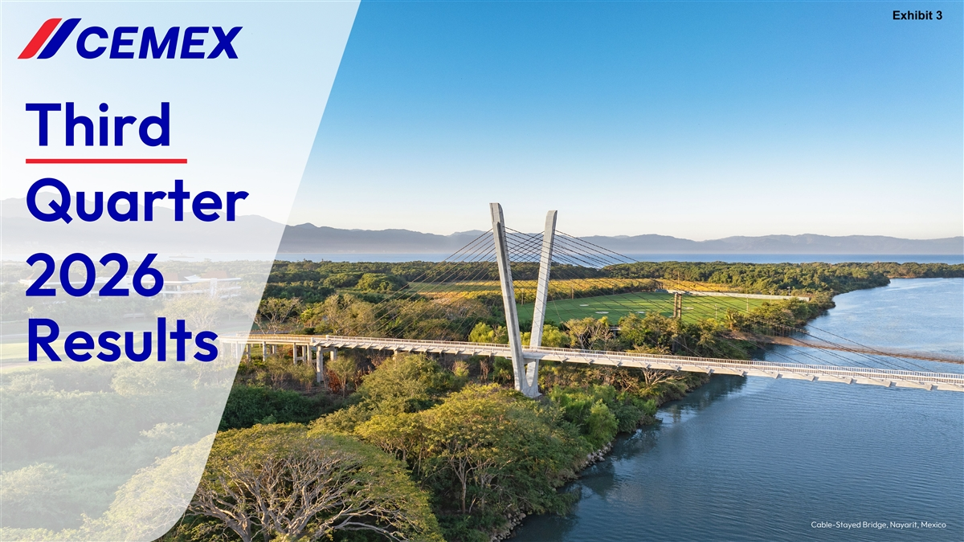
Exhibit 3 Third Quarter 2026 Results Cable-Stayed Bridge, Nayarit, Mexico

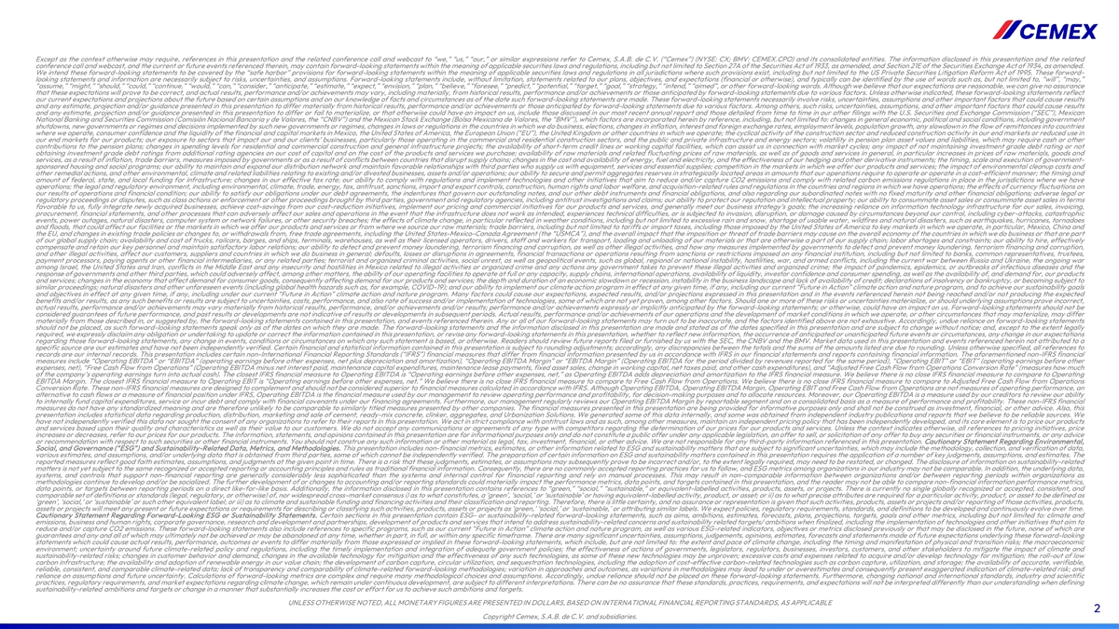
Except as the context otherwise may require, references in this presentation and the related conference call and webcast to “we,” “us,” “our,” or similar expressions refer to Cemex, S.A.B. de C.V. (“Cemex”) (NYSE: CX; BMV: CEMEX.CPO) and its consolidated entities. The information disclosed in this presentation and the related conference call and webcast, and the current or future events referenced therein, may contain forward-looking statements within the meaning of applicable securities laws and regulations, including but not limited to Section 27A of the Securities Act of 1933, as amended, and Section 21E of the Securities Exchange Act of 1934, as amended. We intend these forward-looking statements to be covered by the “safe harbor” provisions for forward-looking statements within the meaning of applicable securities laws and regulations in all jurisdictions where such provisions exist, including but not limited to the US Private Securities Litigation Reform Act of 1995. These forward- looking statements and information are necessarily subject to risks, uncertainties, and assumptions. Forward-looking statements include, without limitation, statements related to our plans, objectives, and expectations (financial or otherwise), and typically can be identified by the use of words such as, but not limited to, “will”, “may,” “assume,” “might,” “should,” “could,” “continue,” “would,” “can,” “consider,” “anticipate,” “estimate,” “expect,” “envision,” “plan,” “believe,” “foresee,” “predict,” “potential,” “target,” “goal,” “strategy,” “intend,” “aimed”, or other forward-looking words. Although we believe that our expectations are reasonable, we can give no assurance that these expectations will prove to be correct, and actual results, performance and/or achievements may vary, including materially, from historical results, performance and/or achievements or those anticipated by forward-looking statements due to various factors. Unless otherwise indicated, these forward-looking statements reflect our current expectations and projections about the future based on certain assumptions and on our knowledge of facts and circumstances as of the date such forward-looking statements are made. These forward-looking statements necessarily involve risks, uncertainties, assumptions and other important factors that could cause results and any estimate, projection and/or guidance presented in this presentation to differ materially from historical results, performance and/or achievements or those anticipated by forward-looking statements due to various factors. Among others, such risks, uncertainties, assumptions, and other important factors that could cause results and any estimate, projection and/or guidance presented in this presentation to differ or fail to materialize, or that otherwise could have an impact on us, include those discussed in our most recent annual report and those detailed from time to time in our other filings with the U.S. Securities and Exchange Commission (“SEC”), Mexican National Banking and Securities Commission (Comisión Nacional Bancaria y de Valores, the “CNBV”) and the Mexican Stock Exchange (Bolsa Mexicana de Valores, the “BMV”), which factors are incorporated herein by reference, including, but not limited to: changes in general economic, political and social conditions, including government shutdowns, new governments or regimes and decisions implemented by such new governments or regimes, changes in laws or regulations in the countries in which we do business, elections, changes in inflation, interest and foreign exchange rates, employment levels, population growth, any slowdown in the flow of remittances into countries where we operate, consumer confidence and the liquidity of the financial and capital markets in Mexico, the United States of America, the European Union (“EU”), the United Kingdom or other countries in which we operate; the cyclical activity of the construction sector and reduced construction activity in our end markets or reduced use in our end markets for our products; our exposure to sectors that impact our and our clients’ businesses, particularly those operating in the commercial and residential construction sectors, and the public and private infrastructure and energy sectors; volatility in pension plan asset values and liabilities, which may require cash or other contributions to the pension plans; changes in spending levels for residential and commercial construction and general infrastructure projects; the availability of short-term credit lines or working capital facilities, which can assist us in connection with market cycles; any impact of not maintaining investment grade debt rating or not obtaining investment grade debt ratings from additional rating agencies on our cost of capital and on the cost of the products and services we purchase; availability of raw materials and related fluctuating prices of raw materials, as well as of goods and services in general, in particular increases in prices of raw materials, goods and services, as a result of inflation, trade barriers, measures imposed by governments or as a result of conflicts between countries that disrupt supply chains; changes in the cost and availability of energy, fuel and electricity, and the effectiveness of our hedging and other derivative instruments; the timing, scale and execution of government- sponsored housing and social programs; our ability to maintain and expand our distribution network and maintain favorable relationships with third parties who supply us with equipment, services and essential supplies; competition in the markets in which we offer our products and services; the impact of environmental cleanup costs and other remedial actions, and other environmental, climate and related liabilities relating to existing and/or divested businesses, assets and/or operations; our ability to secure and permit aggregates reserves in strategically located areas in amounts that our operations require to operate or operate in a cost-efficient manner; the timing and amount of federal, state, and local funding for infrastructure; changes in our effective tax rate; our ability to comply with regulations and implement technologies and other initiatives that aim to reduce and/or capture CO2 emissions and comply with related carbon emissions regulations in place in the jurisdictions where we have operations; the legal and regulatory environment, including environmental, climate, trade, energy, tax, antitrust, sanctions, import and export controls, construction, human rights and labor welfare, and acquisition-related rules and regulations in the countries and regions in which we have operations; the effects of currency fluctuations on our results of operations and financial condition; our ability to satisfy our obligations under our debt agreements, the indentures that govern our outstanding notes, and our other debt instruments and financial obligations, and also regarding our subordinated notes with no fixed maturity and other financial obligations; adverse legal or regulatory proceedings or disputes, such as class actions or enforcement or other proceedings brought by third parties, government and regulatory agencies, including antitrust investigations and claims; our ability to protect our reputation and intellectual property; our ability to consummate asset sales or consummate asset sales in terms favorable to us, fully integrate newly acquired businesses, achieve cost-savings from our cost-reduction initiatives, implement our pricing and commercial initiatives for our products and services, and generally meet our business strategy’s goals; the increasing reliance on information technology infrastructure for our sales, invoicing, procurement, financial statements, and other processes that can adversely affect our sales and operations in the event that the infrastructure does not work as intended, experiences technical difficulties, or is subjected to invasion, disruption, or damage caused by circumstances beyond our control, including cyber-attacks, catastrophic events, power outages, natural disasters, computer system or network failures, or other security breaches; the effects of climate change, in particular reflected in weather conditions, including but not limited to excessive rain and snow, shortage of usable water, wildfires and natural disasters, such as earthquakes, hurricanes, tornadoes and floods, that could affect our facilities or the markets in which we offer our products and services or from where we source our raw materials; trade barriers, including but not limited to tariffs or import taxes, including those imposed by the United States of America to key markets in which we operate, in particular, Mexico, China and the EU, and changes in existing trade policies or changes to, or withdrawals from, free trade agreements, including the United States-Mexico-Canada Agreement (the “USMCA”), and the overall impact that the imposition or threat of trade barriers may cause on the overall economy of the countries in which we do business or that are part of our global supply chain; availability and cost of trucks, railcars, barges, and ships, terminals, warehouses, as well as their licensed operators, drivers, staff and workers for transport, loading and unloading of our materials or that are otherwise a part of our supply chain; labor shortages and constraints; our ability to hire, effectively compensate and retain our key personnel and maintain satisfactory labor relations; our ability to detect and prevent money laundering, terrorism financing and corruption, as well as other illegal activities, and how any measures implemented by governments to detect and prevent money laundering, terrorism financing and corruption, and other illegal activities, affect our customers, suppliers and countries in which we do business in general; defaults, losses or disruptions in agreements, financial transactions or operations resulting from sanctions or restrictions imposed on any financial institution, including but not limited to banks, common representatives, trustees, payment processors, paying agents or other financial intermediaries, or any related parties; terrorist and organized criminal activities, social unrest, as well as geopolitical events, such as global, regional or national instability, hostilities, war, and armed conflicts, including the current war between Russia and Ukraine, the ongoing war among Israel, the United States and Iran, conflicts in the Middle East and any insecurity and hostilities in Mexico related to illegal activities or organized crime and any actions any government takes to prevent these illegal activities and organized crime; the impact of pandemics, epidemics, or outbreaks of infectious diseases and the response of governments and other third parties, which could adversely affect, among other matters, the ability of our operating facilities to operate at full or any capacity, supply chains, international operations, availability of liquidity, investor confidence and consumer spending, as well as the availability of, and demand for, our products and services; changes in the economy that affect demand for consumer goods, consequently affecting demand for our products and services; the depth and duration of an economic slowdown or recession, instability in the business landscape and lack of availability of credit; declarations of insolvency or bankruptcy, or becoming subject to similar proceedings; natural disasters and other unforeseen events (including global health hazards such as, for example, COVID-19); and our ability to implement our climate action program in effect at any given time, if any, including our current “Future in Action” climate action and nature program, and to achieve our sustainability goals and objectives in effect at any given time, if any, including under our current “Future in Action” climate action and nature program. Many factors could cause our expectations, expected results, and/or projections expressed in this presentation and in the events referenced herein not being reached and/or not producing the expected benefits and/or results, as any such benefits or results are subject to uncertainties, costs, performance, and also rate of success and/or implementation of technologies, some of which are not yet proven, among other factors. Should one or more of these risks or uncertainties materialize, or should underlying assumptions prove incorrect, actual results, performance and/or achievements may vary materially from historical results, performance, and/or achievements and/or results; performance and/or achievements expressly or implicitly anticipated by the forward-looking statements; or otherwise, could have an impact on us. Forward-looking statements should not be considered guarantees of future performance, and past results or developments are not indicative of results or developments in subsequent periods. Actual results, performance and/or achievements of our operations and the development of market conditions in which we operate, or other circumstances that may materialize, may differ materially from those described in, or suggested by, the forward-looking statements contained in this presentation, and events referenced therein. Any or all of our forward-looking statements may turn out to be inaccurate, and the factors identified above are not exhaustive. Accordingly, undue reliance on forward-looking statements should not be placed, as such forward-looking statements speak only as of the dates on which they are made. The forward-looking statements and the information disclosed in this presentation are made and stated as of the dates specified in this presentation and are subject to change without notice; and, except to the extent legally required, we expressly disclaim any obligation or undertaking to update or correct the information contained in this presentation, or revise any forward-looking statements in this presentation, whether to reflect new information, the occurrence of anticipated or unanticipated future events or circumstances, any change in our expectations regarding those forward-looking statements, any change in events, conditions or circumstances on which any such statement is based, or otherwise. Readers should review future reports filed or furnished by us with the SEC, the CNBV and the BMV. Market data used in this presentation and events referenced herein not attributed to a specific source are our estimates and have not been independently verified. Certain financial and statistical information contained in this presentation is subject to rounding adjustments; accordingly, any discrepancies between the totals and the sums of the amounts listed are due to rounding. Unless otherwise specified, all references to records are our internal records. This presentation includes certain non-International Financial Reporting Standards (“IFRS”) financial measures that differ from financial information presented by us in accordance with IFRS in our financial statements and reports containing financial information. The aforementioned non-IFRS financial measures include “Operating EBITDA” or “EBITDA” (operating earnings before other expenses, net plus depreciation and amortization), “Operating EBITDA Margin” or “EBITDA Margin” (Operating EBITDA for the period divided by revenues reported for the same period), “Operating EBIT” or “EBIT” (operating earnings before other expenses, net), “Free Cash Flow from Operations” (Operating EBITDA minus net interest paid, maintenance capital expenditures, maintenance lease payments, fixed asset sales, change in working capital, net taxes paid, and other cash expenditures), and “Adjusted Free Cash Flow from Operations Conversion Rate” (measures how much of the company’s operating earnings turn into actual cash). The closest IFRS financial measure to Operating EBITDA is “Operating earnings before other expenses, net,” as Operating EBITDA adds depreciation and amortization to the IFRS financial measure. We believe there is no close IFRS financial measure to compare to Operating EBITDA Margin. The closest IFRS financial measure to Operating EBIT is “Operating earnings before other expenses, net.” We believe there is no close IFRS financial measure to compare to Free Cash Flow from Operations. We believe there is no close IFRS financial measure to compare to Adjusted Free Cash Flow from Operations Conversion Rate. These non-IFRS financial measures are designed to complement and should not be considered superior to financial measures calculated in accordance with IFRS. Although Operating EBITDA, Operating EBITDA Margin, Operating EBIT and Free Cash Flow from Operations are not measures of operating performance, an alternative to cash flows or a measure of financial position under IFRS, Operating EBITDA is the financial measure used by our management to review operating performance and profitability, for decision-making purposes and to allocate resources. Moreover, our Operating EBITDA is a measure used by our creditors to review our ability to internally fund capital expenditures, service or incur debt and comply with financial covenants under our financing agreements. Furthermore, our management regularly reviews our Operating EBITDA Margin by reportable segment and on a consolidated basis as a measure of performance and profitability. These non-IFRS financial measures do not have any standardized meaning and are therefore unlikely to be comparable to similarly titled measures presented by other companies. The financial measures presented in this presentation are being provided for informative purposes only and shall not be construed as investment, financial, or other advice. Also, this presentation includes statistical data regarding production, distribution, marketing and sale of cement, ready-mix concrete, clinker, aggregates, and Urbanization Solutions. We generated some of this data internally, and some was obtained from independent industry publications and reports that we believe to be reliable sources. We have not independently verified this data nor sought the consent of any organizations to refer to their reports in this presentation. We act in strict compliance with antitrust laws and as such, among other measures, maintain an independent pricing policy that has been independently developed, and its core element is to price our products and services based upon their quality and characteristics as well as their value to our customers. We do not accept any communications or agreements of any type with competitors regarding the determination of our prices for our products and services. Unless the context indicates otherwise, all references to pricing initiatives, price increases or decreases, refer to our prices for our products. The information, statements, and opinions contained in this presentation are for informational purposes only and do not constitute a public offer under any applicable legislation, an offer to sell, or solicitation of any offer to buy any securities or financial instruments, or any advice or recommendation with respect to such securities or other financial instruments. You should not construe any such information or other material as legal, tax, investment, financial, or other advice. We are not responsible for any third-party information referenced in this presentation. Cautionary Statement Regarding Environmental, Social, and Governance (“ESG”) and Sustainability-Related Data, Metrics, and Methodologies. This presentation includes non-financial metrics, estimates, or other information related to ESG and sustainability matters that are subject to significant uncertainties, which may include the methodology, collection, and verification of data, various estimates, and assumptions, and/or underlying data that is obtained from third parties, some of which cannot be independently verified. The preparation of certain information on ESG and sustainability matters contained in this presentation requires the application of a number of key judgments, assumptions, and estimates. The reported measures reflect good faith estimates, assumptions, and judgments at the given point in time. There is a risk that these judgments, estimates, or assumptions may subsequently prove to be incorrect and/or, to the extent legally required, may need to be restated, or changed. The disclosure of information on sustainability-related matters is not yet subject to the same recognized or accepted reporting or accounting principles and rules as traditional financial information. Consequently, there are no commonly accepted reporting practices for us to follow, and ESG metrics among organizations in our industry may not be comparable. In addition, the underlying data, systems, and controls that support non-financial reporting are generally considerably less sophisticated than the systems and internal control for financial reporting and rely on manual processes. This may result in non-comparable information between organizations and/or between reporting periods within organizations as methodologies continue to develop and/or be socialized. The further development of or changes to accounting and/or reporting standards could materially impact the performance metrics, data points, and targets contained in this presentation, and the reader may not be able to compare non-financial information performance metrics, data points, or targets between reporting periods on a direct like-for-like basis. Additionally, the information disclosed in this presentation contains references to “green,” “social,” “sustainable,” or equivalent-labelled activities, products, assets, or projects. There is currently no single globally recognized or accepted, consistent, and comparable set of definitions or standards (legal, regulatory, or otherwise) of, nor widespread cross-market consensus i) as to what constitutes, a ‘green’, ‘social,’ or ‘sustainable’ or having equivalent-labelled activity, product, or asset; or ii) as to what precise attributes are required for a particular activity, product, or asset to be defined as ‘green’, ‘social,’ or ‘sustainable’ or such other equivalent label; or iii) as to climate and sustainable funding and financing activities and their classification and reporting. Therefore, there is little certainty, and no assurance or representation is given that such activities, products, assets or projects and/or reporting of those activities, products, assets or projects will meet any present or future expectations or requirements for describing or classifying such activities, products, assets or projects as ‘green,’ ‘social,’ or ‘sustainable,’ or attributing similar labels. We expect policies, regulatory requirements, standards, and definitions to be developed and continuously evolve over time. Cautionary Statement Regarding Forward-Looking ESG or Sustainability Statements. Certain sections in this presentation contain ESG- or sustainability-related forward-looking statements, such as aims, ambitions, estimates, forecasts, plans, projections, targets, goals and other metrics, including but not limited to: climate and emissions, business and human rights, corporate governance, research and development and partnerships, development of products and services that intend to address sustainability-related concerns and sustainability related targets/ ambitions when finalized, including the implementation of technologies and other initiatives that aim to reduce and/or capture CO2 emissions. These forward-looking statements also include references to specific programs, such as our current “Future in Action” climate action and nature program, as well as various ESG-related indicators, objectives or metrics disclosed previously or that may be disclosed in the future, none of which are guarantees and any and all of which may ultimately not be achieved or may be abandoned at any time, whether in part, in full, or within any specific timeframe. There are many significant uncertainties, assumptions, judgements, opinions, estimates, forecasts and statements made of future expectations underlying these forward-looking statements which could cause actual results, performance, outcomes or events to differ materially from those expressed or implied in these forward-looking statements, which include, but are not limited to: the extent and pace of climate change, including the timing and manifestation of physical and transition risks; the macroeconomic environment; uncertainty around future climate-related policy and regulations, including the timely implementation and integration of adequate government policies; the effectiveness of actions of governments, legislators, regulators, businesses, investors, customers, and other stakeholders to mitigate the impact of climate and sustainability-related risks; changes in customer behavior and demand, changes in the available technology for mitigation and the effectiveness of any such technologies, as some of these new technologies may be unproven; excessive costs and expenses related to acquire and/or develop technology for mitigation; the roll-out of low carbon infrastructure; the availability and adoption of renewable energy in our value chain; the development of carbon capture, circular utilization, and sequestration technologies, including the adoption of cost-effective carbon-related technologies such as carbon capture, utilization, and storage; the availability of accurate, verifiable, reliable, consistent, and comparable climate-related data; lack of transparency and comparability of climate-related forward-looking methodologies; variation in approaches and outcomes, as variations in methodologies may lead to under or overestimates and consequently present exaggerated indication of climate-related risk; and reliance on assumptions and future uncertainty. Calculations of forward-looking metrics are complex and require many methodological choices and assumptions. Accordingly, undue reliance should not be placed on these forward-looking statements. Furthermore, changing national and international standards, industry and scientific practices, regulatory requirements, and market expectations regarding climate change, which remain under continuous development, are subject to different interpretations. There can be no assurance that these standards, practices, requirements, and expectations will not be interpreted differently than our understanding when defining sustainability-related ambitions and targets or change in a manner that substantially increases the cost or effort for us to achieve such ambitions and targets. UNLESS OTHERWISE NOTED, ALL MONETARY FIGURES ARE PRESENTED IN DOLLARS, BASED ON INTERNATIONAL FINANCIAL REPORTING STANDARDS, AS APPLICABLE 2 Copyright Cemex, S.A.B. de C.V. and subsidiaries.

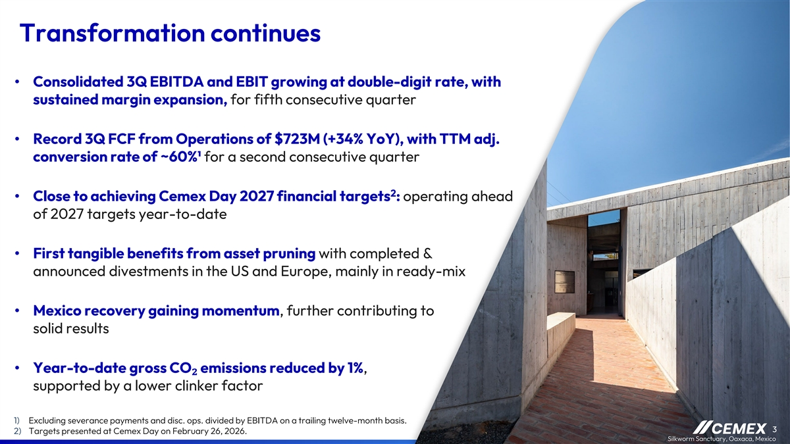
Transformation continues • Consolidated 3Q EBITDA and EBIT growing at double-digit rate, with sustained margin expansion, for fifth consecutive quarter • Record 3Q FCF from Operations of $723M (+34% YoY), with TTM adj. conversion rate of ~60%¹ for a second consecutive quarter 2 • Close to achieving Cemex Day 2027 financial targets : operating ahead of 2027 targets year-to-date • First tangible benefits from asset pruning with completed & announced divestments in the US and Europe, mainly in ready-mix • Mexico recovery gaining momentum, further contributing to solid results • Year-to-date gross CO₂ emissions reduced by 1%, supported by a lower clinker factor 1) Excluding severance payments and disc. ops. divided by EBITDA on a trailing twelve-month basis. 3 2) Targets presented at Cemex Day on February 26, 2026. Silkworm Sanctuary, Oaxaca, Mexico

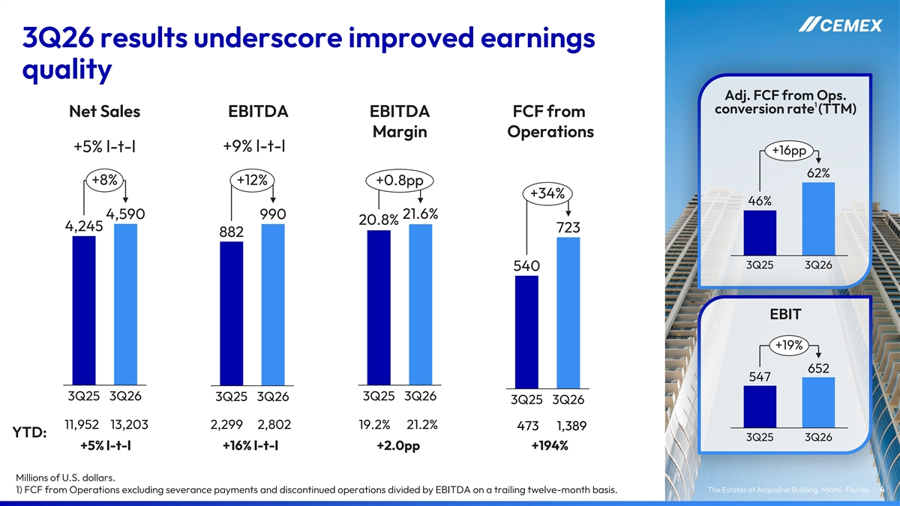
3Q26 results underscore improved earnings quality Adj. FCF from Ops. 1 conversion rate (TTM) Net Sales EBITDA EBITDA FCF from Margin Operations +9% l-t-l +5% l-t-l +16pp 62% +8% +12% +0.8pp +34% 46% 4,590 990 21.6% 20.8% 4,245 723 882 3Q25 3Q26 540 EBIT +19% 652 547 3Q25 3Q26 3Q25 3Q26 3Q25 3Q26 3Q25 3Q26 11,952 13,203 2,299 2,802 19.2% 21.2% 473 1,389 YTD: 3Q25 3Q26 +5% l-t-l +16% l-t-l +2.0pp +194% Millions of U.S. dollars. The Estates at Acqualina Building, Miami, Florida 1) FCF from Operations excluding severance payments and discontinued operations divided by EBITDA on a trailing twelve-month basis. 4

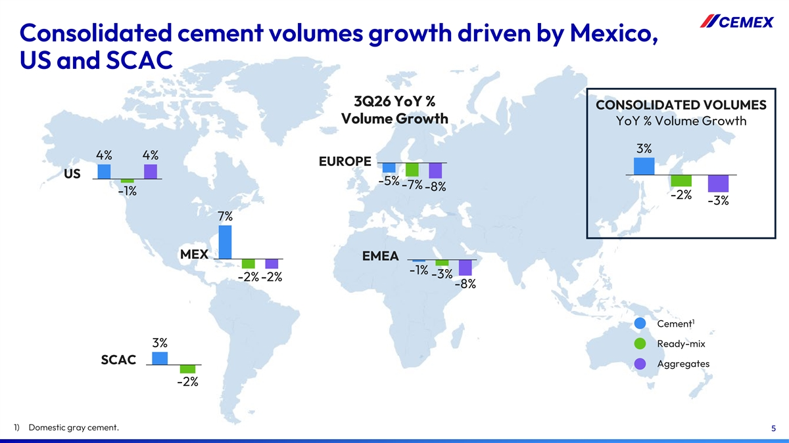
Consolidated cement volumes growth driven by Mexico, US and SCAC 3Q26 YoY % CONSOLIDATED VOLUMES Volume Growth YoY % Volume Growth 3% 4% 4% EUROPE US -5% -7% -8% -1% -2% -3% 7% MEX EMEA -1% -3% -2% -2% -8% 1 Cement 3% Ready-mix SCAC Aggregates -2% 1) Domestic gray cement. 5

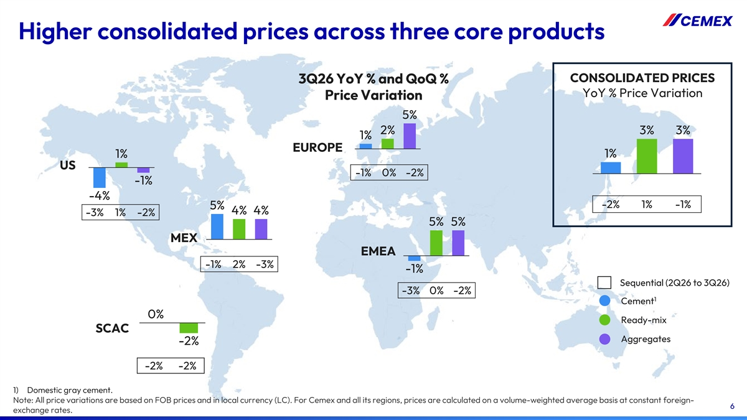
Higher consolidated prices across three core products CONSOLIDATED PRICES 3Q26 YoY % and QoQ % YoY % Price Variation Price Variation 5% 2% 3% 3% 1% EUROPE 1% 1% US -1% 0% -2% -1% -4% -2% 1% -1% 5% 4% 4% -3% 1% -2% 5% 5% MEX EMEA -1% 2% -3% -1% Sequential (2Q26 to 3Q26) -3% 0% -2% 1 Cement 0% Ready-mix SCAC Aggregates -2% -2% -2% 1) Domestic gray cement. Note: All price variations are based on FOB prices and in local currency (LC). For Cemex and all its regions, prices are calculated on a volume-weighted average basis at constant foreign- 6 exchange rates.

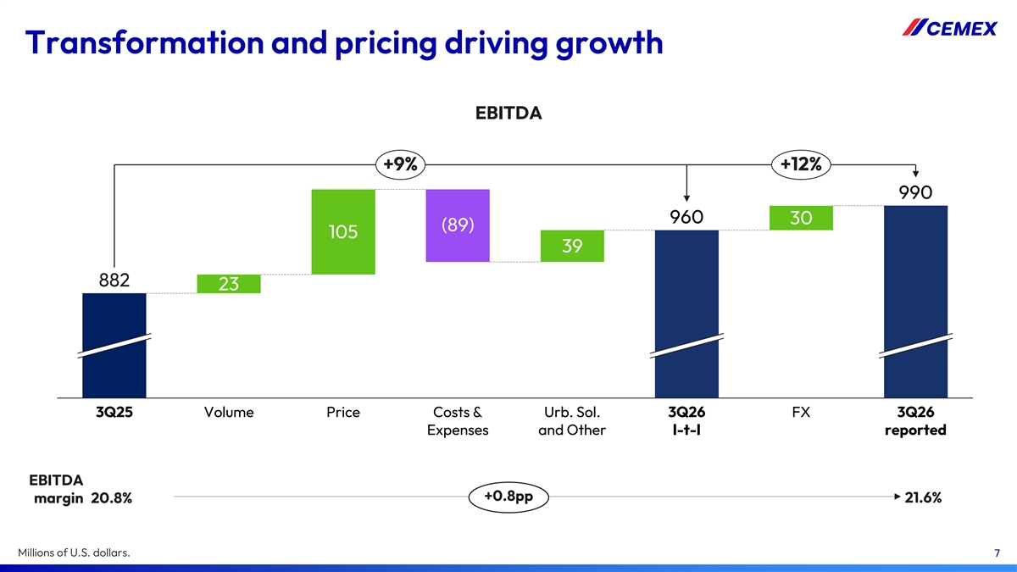
Transformation and pricing driving growth EBITDA +9% +12% 990 960 30 (89) 105 39 882 23 3Q25 Volume Price Costs & Urb. Sol. 3Q26 FX 3Q26 Expenses and Other l-t-l reported EBITDA +0.8pp margin 20.8% 21.6% Millions of U.S. dollars. 7

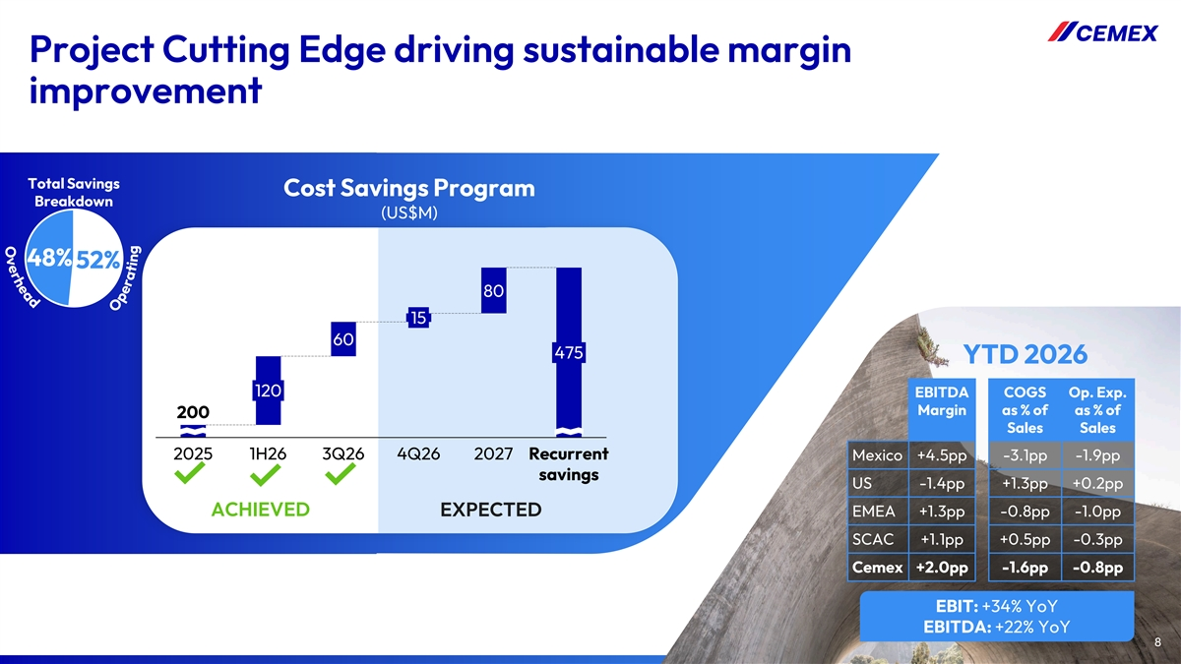
Project Cutting Edge driving sustainable margin improvement Total Savings Cost Savings Program Breakdown (US$M) 48% 52% 80 15 60 475 YTD 2026 120 EBITDA COGS Op. Exp. Margin as % of as % of 200 Sales Sales 2025 1H26 3Q26 4Q26 2027 Recurrent Mexico +4.5pp -3.1pp -1.9pp savings US -1.4pp +1.3pp +0.2pp ACHIEVED EXPECTED EMEA +1.3pp -0.8pp -1.0pp SCAC +1.1pp +0.5pp -0.3pp Cemex +2.0pp -1.6pp -0.8pp EBIT: +34% YoY EBITDA: +22% YoY 8 8

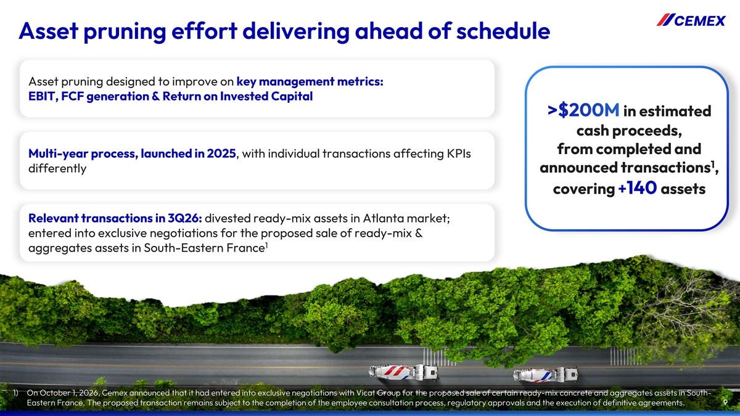
Asset pruning effort delivering ahead of schedule Asset pruning designed to improve on key management metrics: EBIT, FCF generation & Return on Invested Capital in estimated cash proceeds, from completed and Multi-year process, launched in 2025, with individual transactions affecting KPIs 1 differently announced transactions , covering assets Relevant transactions in 3Q26: divested ready-mix assets in Atlanta market; entered into exclusive negotiations for the proposed sale of ready-mix & 1 aggregates assets in South-Eastern France 1) On October 1, 2026, Cemex announced that it had entered into exclusive negotiations with Vicat Group for the proposed sale of certain ready-mix concrete and aggregates assets in South- Eastern France. The proposed transaction remains subject to the completion of the employee consultation process, regulatory approvals and the execution of definitive agreements. 9


Regional Highlights L'Arbre Blanc, Montpellier, France

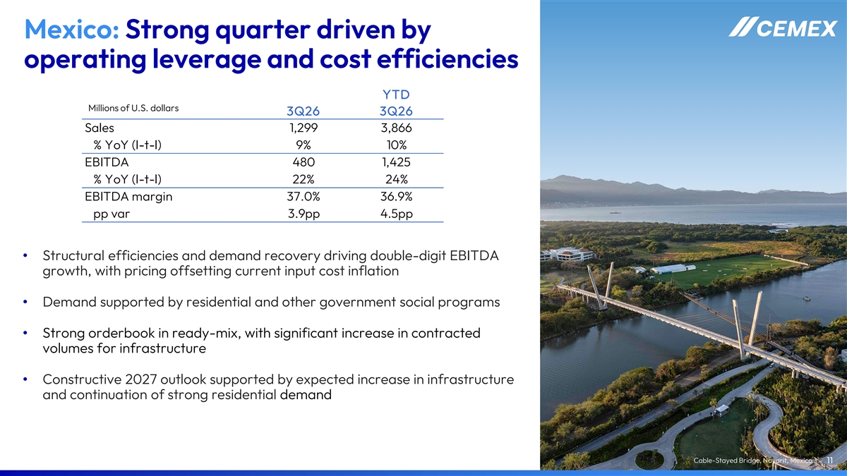
Mexico: Strong quarter driven by operating leverage and cost efficiencies YTD Millions of U.S. dollars 3Q26 3Q26 Sales 1,299 3,866 % YoY (l-t-l) 9% 10% EBITDA 480 1,425 % YoY (l-t-l) 22% 24% EBITDA margin 37.0% 36.9% pp var 3.9pp 4.5pp • Structural efficiencies and demand recovery driving double-digit EBITDA growth, with pricing offsetting current input cost inflation • Demand supported by residential and other government social programs • Strong orderbook in ready-mix, with significant increase in contracted volumes for infrastructure • Constructive 2027 outlook supported by expected increase in infrastructure and continuation of strong residential demand Cable-Stayed Bridge, Nayarit, Mexico 11

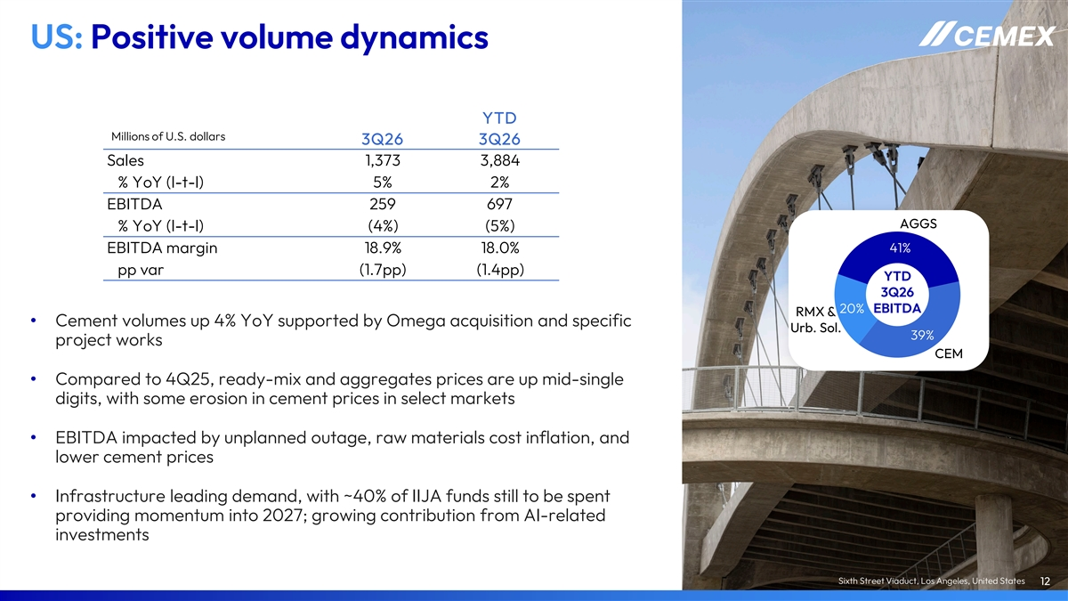
US: Positive volume dynamics YTD Millions of U.S. dollars 3Q26 3Q26 Sales 1,373 3,884 % YoY (l-t-l) 5% 2% EBITDA 259 697 AGGS % YoY (l-t-l) (4%) (5%) 41% EBITDA margin 18.9% 18.0% pp var (1.7pp) (1.4pp) YTD 3Q26 20% EBITDA RMX & • Cement volumes up 4% YoY supported by Omega acquisition and specific Urb. Sol. 39% project works CEM • Compared to 4Q25, ready-mix and aggregates prices are up mid-single digits, with some erosion in cement prices in select markets • EBITDA impacted by unplanned outage, raw materials cost inflation, and lower cement prices • Infrastructure leading demand, with ~40% of IIJA funds still to be spent providing momentum into 2027; growing contribution from AI-related investments Sixth Street Viaduct, Los Angeles, United States 12

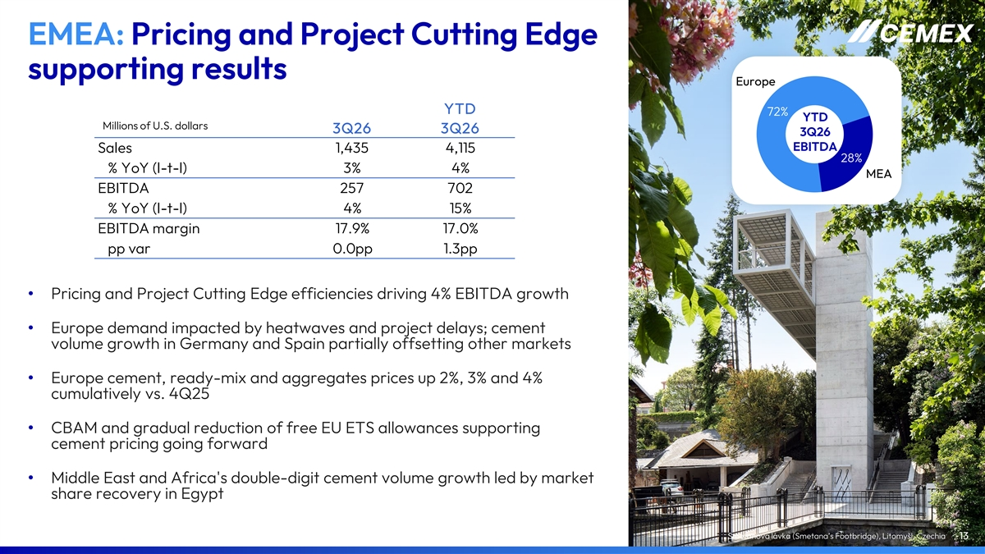
EMEA: Pricing and Project Cutting Edge supporting results Europe YTD 72% YTD Millions of U.S. dollars 3Q26 3Q26 3Q26 EBITDA Sales 1,435 4,115 28% % YoY (l-t-l) 3% 4% MEA EBITDA 257 702 % YoY (l-t-l) 4% 15% EBITDA margin 17.9% 17.0% pp var 0.0pp 1.3pp • Pricing and Project Cutting Edge efficiencies driving 4% EBITDA growth • Europe demand impacted by heatwaves and project delays; cement volume growth in Germany and Spain partially offsetting other markets • Europe cement, ready-mix and aggregates prices up 2%, 3% and 4% cumulatively vs. 4Q25 • CBAM and gradual reduction of free EU ETS allowances supporting cement pricing going forward • Middle East and Africa's double-digit cement volume growth led by market share recovery in Egypt Smetanova lávka (Smetana’s Footbridge), Litomyšl, Czechia 13

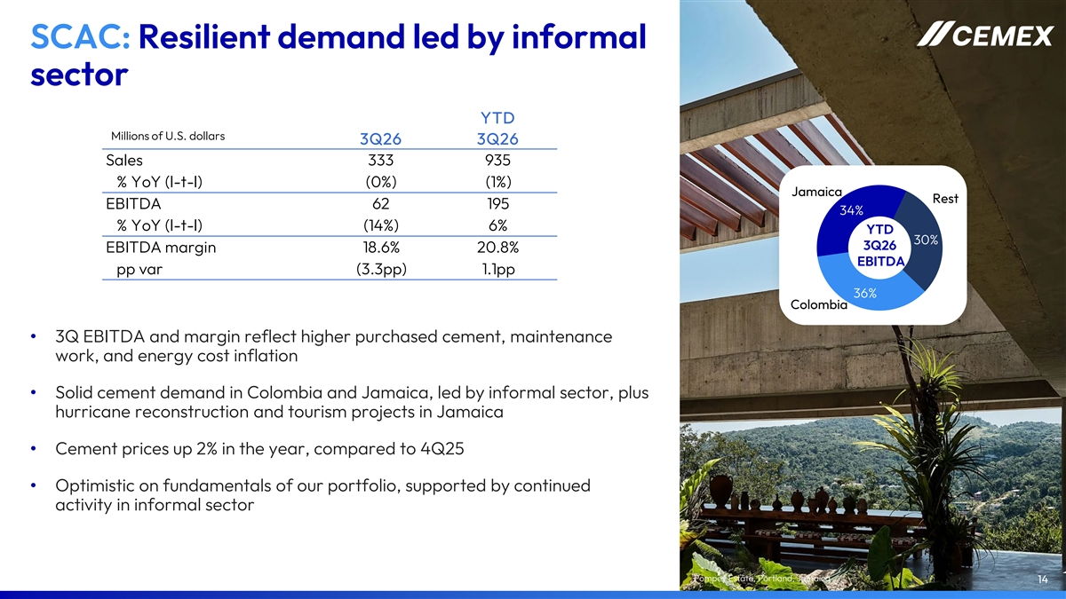
SCAC: Resilient demand led by informal sector YTD Millions of U.S. dollars 3Q26 3Q26 Sales 333 935 % YoY (l-t-l) (0%) (1%) Jamaica Rest EBITDA 62 195 34% % YoY (l-t-l) (14%) 6% YTD 30% 3Q26 EBITDA margin 18.6% 20.8% EBITDA pp var (3.3pp) 1.1pp 36% Colombia • 3Q EBITDA and margin reflect higher purchased cement, maintenance work, and energy cost inflation • Solid cement demand in Colombia and Jamaica, led by informal sector, plus hurricane reconstruction and tourism projects in Jamaica • Cement prices up 2% in the year, compared to 4Q25 • Optimistic on fundamentals of our portfolio, supported by continued activity in informal sector Pompey Estate, Portland, Jamaica 14


Financial Developments Pelješac Bridge, Pelješac, Croatia Built with Vertua Concrete, part of our Vertua family of products.

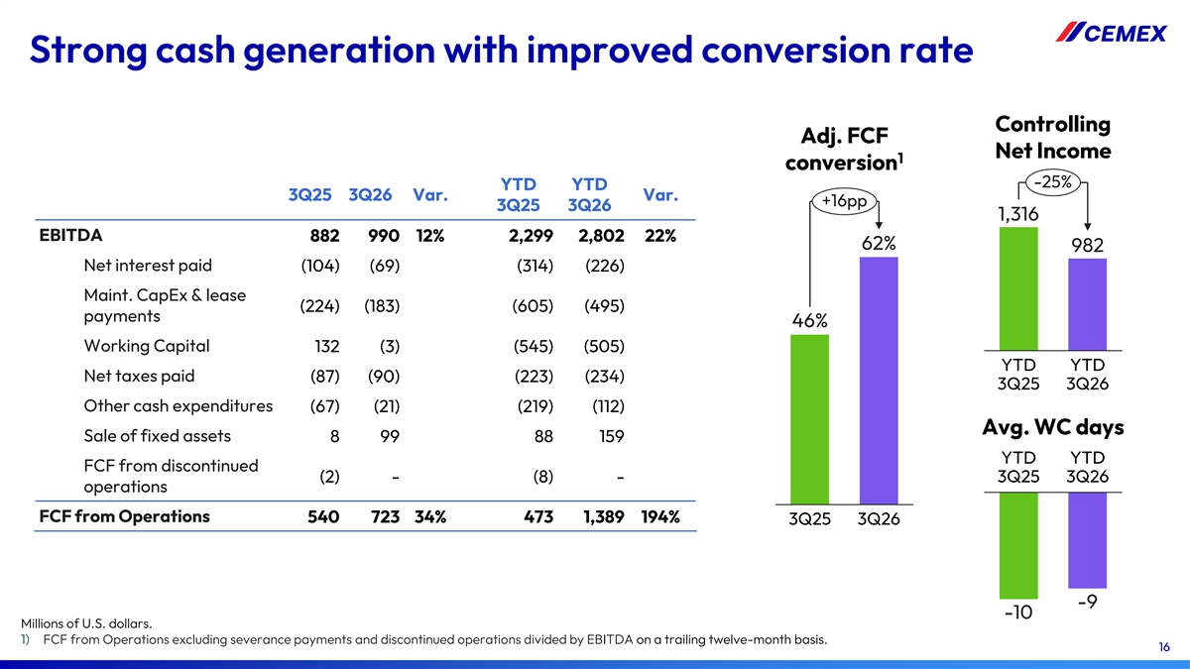
Strong cash generation with improved conversion rate Controlling Adj. FCF Net Income 1 conversion -25% YTD YTD 3Q25 3Q26 Var. Var. +16pp 3Q25 3Q26 1,316 EBITDA 882 990 12% 2,299 2,802 22% 62% 982 Net interest paid (104) (69) (314) (226) Maint. CapEx & lease (224) (183) (605) (495) payments 46% Working Capital 132 (3) (545) (505) YTD YTD Net taxes paid (87) (90) (223) (234) 3Q25 3Q26 Other cash expenditures (67) (21) (219) (112) Avg. WC days Sale of fixed assets 8 99 88 159 YTD YTD FCF from discontinued (2) - (8) - 3Q25 3Q26 operations FCF from Operations 540 723 34% 473 1,389 194% 3Q25 3Q26 -9 -10 Millions of U.S. dollars. 1) FCF from Operations excluding severance payments and discontinued operations divided by EBITDA on a trailing twelve-month basis. 16


2026 Outlook Gilbert Chabroux School, Lyon, France Built with Insularis, part of our Vertua family of products.

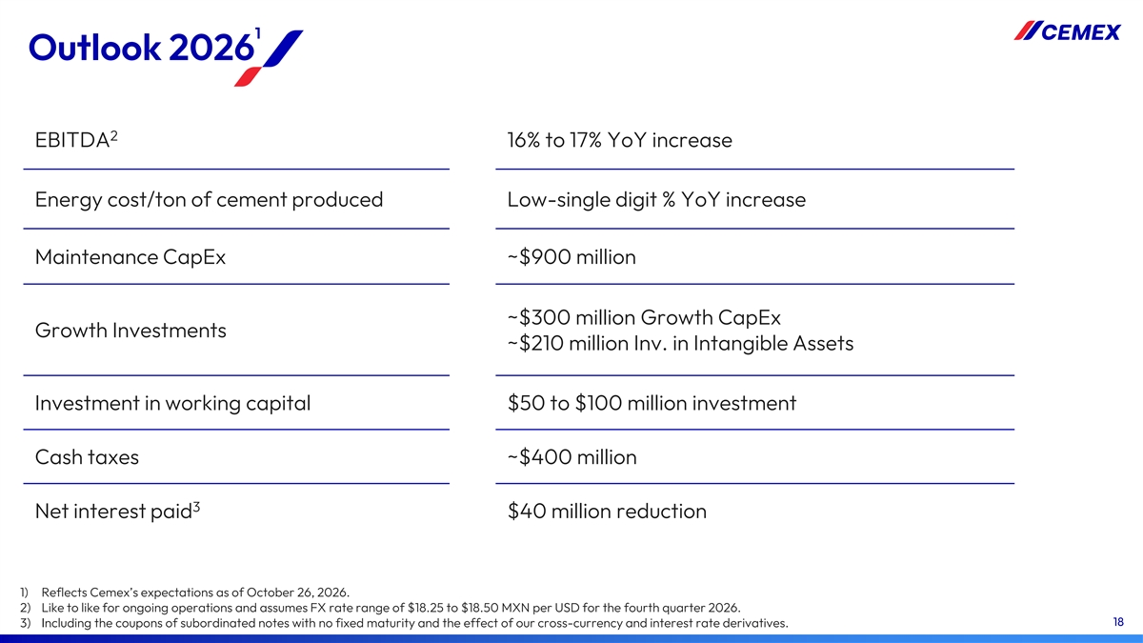
1 Outlook 2026 2 EBITDA 16% to 17% YoY increase Energy cost/ton of cement produced Low-single digit % YoY increase Maintenance CapEx ~$900 million ~$300 million Growth CapEx Growth Investments ~$210 million Inv. in Intangible Assets Investment in working capital $50 to $100 million investment Cash taxes ~$400 million 3 Net interest paid $40 million reduction 1) Reflects Cemex’s expectations as of October 26, 2026. 2) Like to like for ongoing operations and assumes FX rate range of $18.25 to $18.50 MXN per USD for the fourth quarter 2026. 18 3) Including the coupons of subordinated notes with no fixed maturity and the effect of our cross-currency and interest rate derivatives.


Appendix International Museum of Baroque, Puebla, Mexico

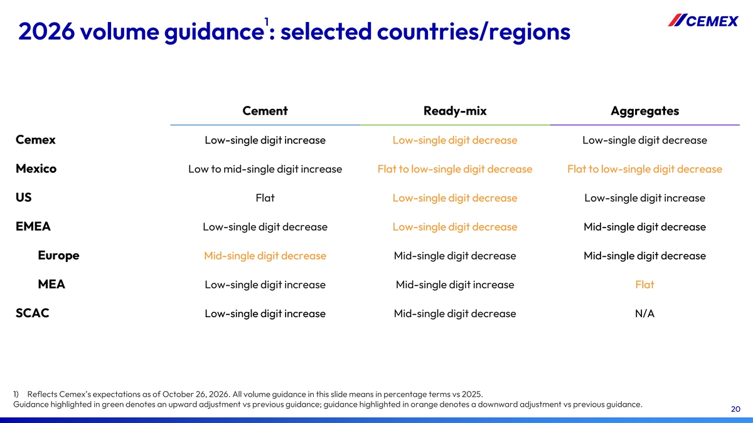
1 2026 volume guidance : selected countries/regions Cement Ready-mix Aggregates Cemex Low-single digit increase Low-single digit decrease Low-single digit decrease Mexico Low to mid-single digit increase Flat to low-single digit decrease Flat to low-single digit decrease Flat Low-single digit decrease Low-single digit increase US EMEA Low-single digit decrease Low-single digit decrease Mid-single digit decrease Europe Mid-single digit decrease Mid-single digit decrease Mid-single digit decrease MEA Low-single digit increase Mid-single digit increase Flat SCAC Low-single digit increase Mid-single digit decrease N/A 1) Reflects Cemex’s expectations as of October 26, 2026. All volume guidance in this slide means in percentage terms vs 2025. Guidance highlighted in green denotes an upward adjustment vs previous guidance; guidance highlighted in orange denotes a downward adjustment vs previous guidance. 20

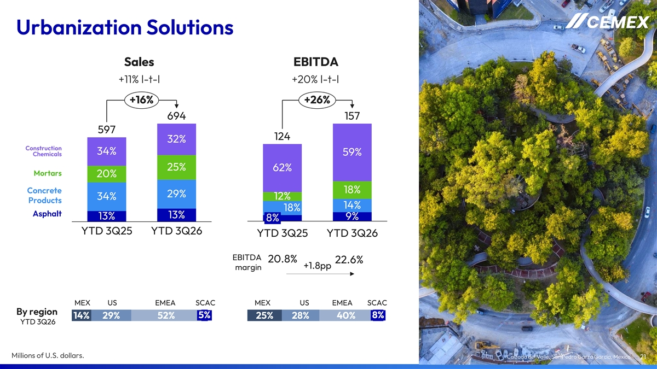
Urbanization Solutions Sales EBITDA +11% l-t-l +20% l-t-l +16% +26% 694 157 597 124 32% Construction 34% 59% Chemicals 25% 62% Mortars 20% Concrete 18% 29% 12% 34% Products 14% 18% Asphalt 13% 13% 9% 8% YTD 3Q25 YTD 3Q26 YTD 3Q25 YTD 3Q26 EBITDA 20.8% 22.6% +1.8pp margin MEX US EMEA SCAC MEX US EMEA SCAC By region 5% 8% 14% 29% 52% 25% 28% 40% YTD 3Q26 Millions of U.S. dollars. Calzada del Valle, San Pedro Garza García, Mexico 21

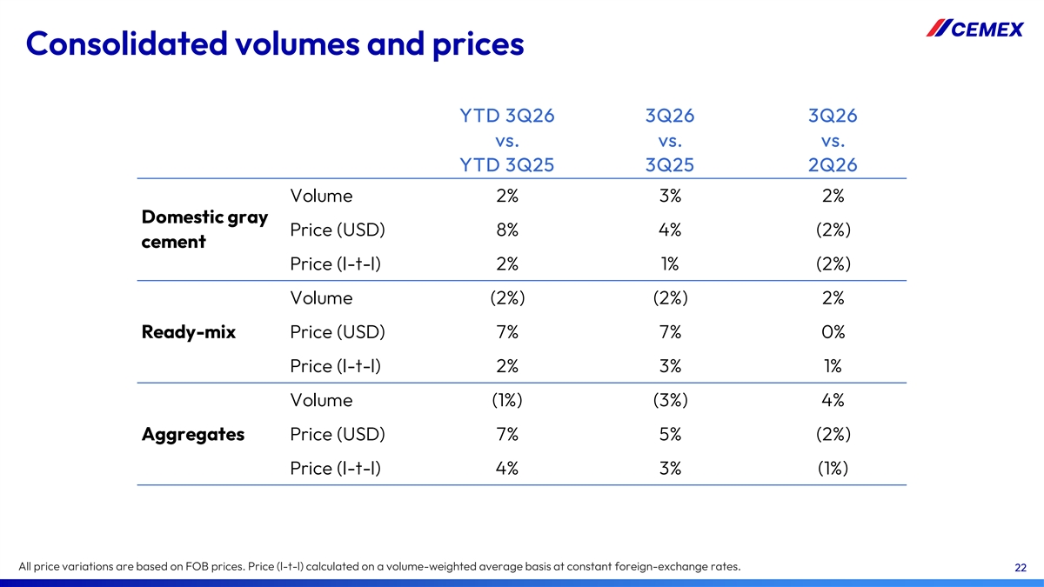
Consolidated volumes and prices YTD 3Q26 3Q26 3Q26 vs. vs. vs. YTD 3Q25 3Q25 2Q26 Volume 2% 3% 2% Domestic gray Price (USD) 8% 4% (2%) cement Price (l-t-l) 2% 1% (2%) Volume (2%) (2%) 2% Ready-mix Price (USD) 7% 7% 0% Price (l-t-l) 2% 3% 1% Volume (1%) (3%) 4% Aggregates Price (USD) 7% 5% (2%) Price (l-t-l) 4% 3% (1%) All price variations are based on FOB prices. Price (l-t-l) calculated on a volume-weighted average basis at constant foreign-exchange rates. 22

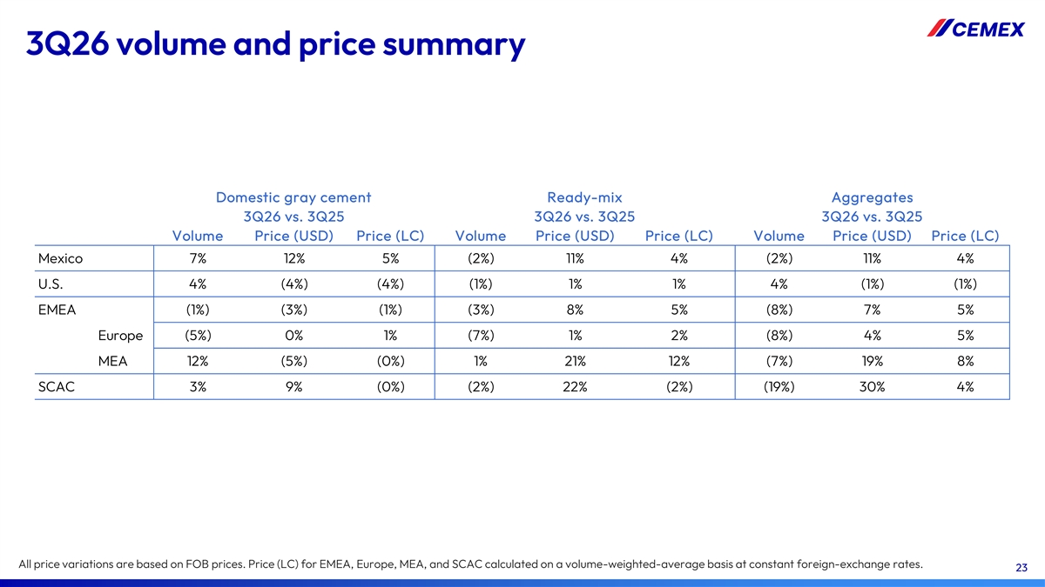
3Q26 volume and price summary Domestic gray cement Ready-mix Aggregates 3Q26 vs. 3Q25 3Q26 vs. 3Q25 3Q26 vs. 3Q25 Volume Price (USD) Price (LC) Volume Price (USD) Price (LC) Volume Price (USD) Price (LC) Mexico 7% 12% 5% (2%) 11% 4% (2%) 11% 4% U.S. 4% (4%) (4%) (1%) 1% 1% 4% (1%) (1%) EMEA (1%) (3%) (1%) (3%) 8% 5% (8%) 7% 5% Europe (5%) 0% 1% (7%) 1% 2% (8%) 4% 5% MEA 12% (5%) (0%) 1% 21% 12% (7%) 19% 8% SCAC 3% 9% (0%) (2%) 22% (2%) (19%) 30% 4% All price variations are based on FOB prices. Price (LC) for EMEA, Europe, MEA, and SCAC calculated on a volume-weighted-average basis at constant foreign-exchange rates. 23

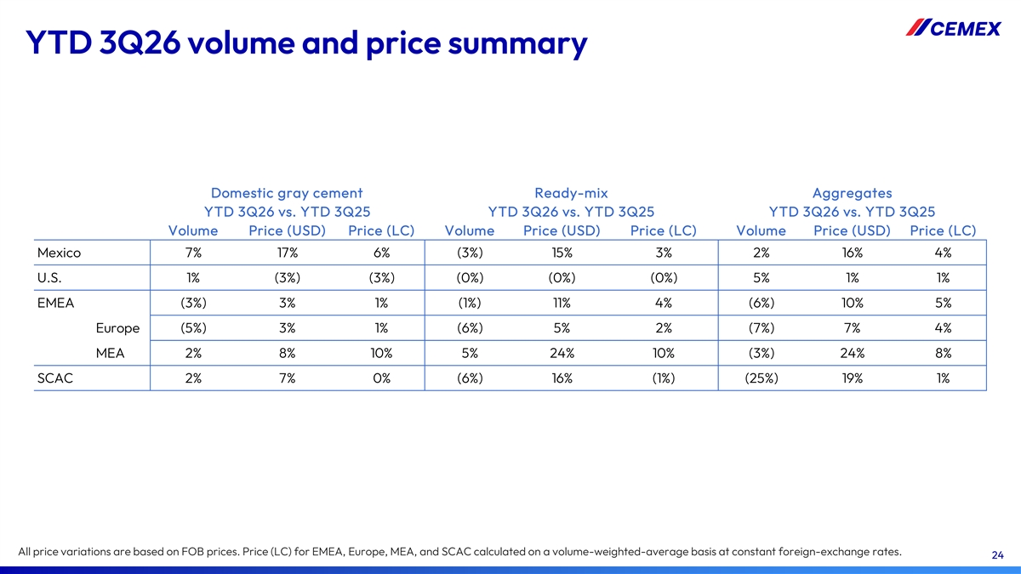
YTD 3Q26 volume and price summary Domestic gray cement Ready-mix Aggregates YTD 3Q26 vs. YTD 3Q25 YTD 3Q26 vs. YTD 3Q25 YTD 3Q26 vs. YTD 3Q25 Volume Price (USD) Price (LC) Volume Price (USD) Price (LC) Volume Price (USD) Price (LC) Mexico 7% 17% 6% (3%) 15% 3% 2% 16% 4% U.S. 1% (3%) (3%) (0%) (0%) (0%) 5% 1% 1% EMEA (3%) 3% 1% (1%) 11% 4% (6%) 10% 5% Europe (5%) 3% 1% (6%) 5% 2% (7%) 7% 4% MEA 2% 8% 10% 5% 24% 10% (3%) 24% 8% SCAC 2% 7% 0% (6%) 16% (1%) (25%) 19% 1% All price variations are based on FOB prices. Price (LC) for EMEA, Europe, MEA, and SCAC calculated on a volume-weighted-average basis at constant foreign-exchange rates. 24

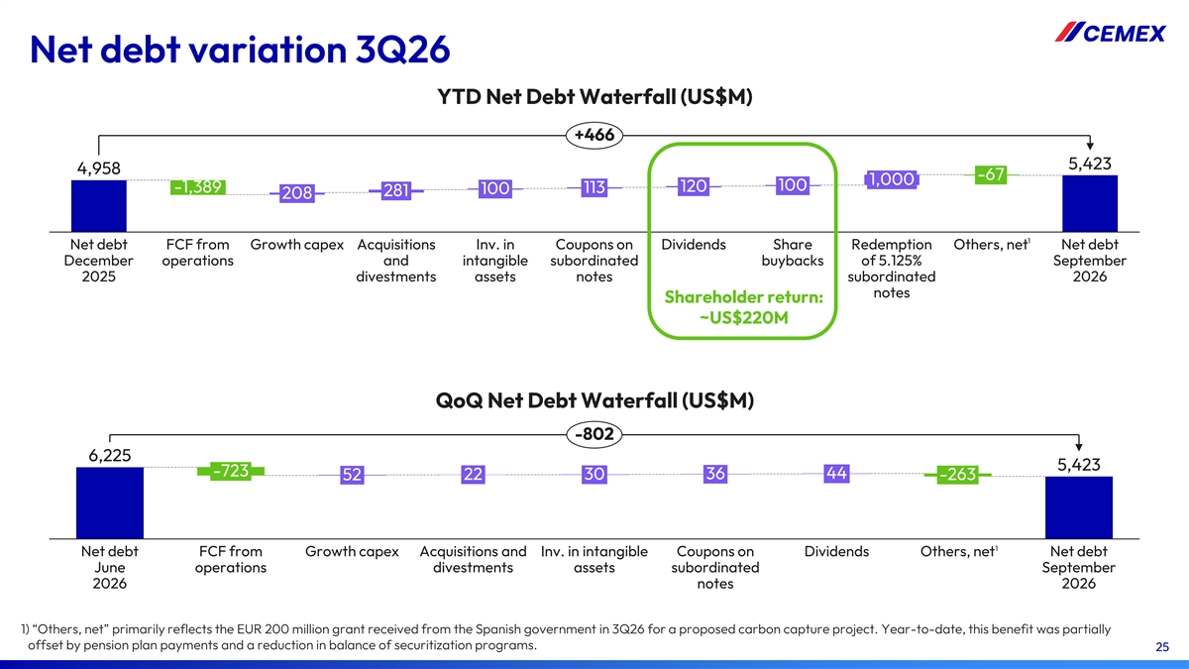
Net debt variation 3Q26 YTD Net Debt Waterfall (US$M) +466 5,423 4,958 -67 1,000 100 120 -1,389 113 100 281 208 1 Net debt FCF from Growth capex Acquisitions Inv. in Coupons on Dividends Share Redemption Others, net Net debt December operations and intangible subordinated buybacks of 5.125% September 2025 divestments assets notes subordinated 2026 notes Shareholder return: ~US$220M QoQ Net Debt Waterfall (US$M) -802 6,225 5,423 -723 30 36 44 52 22 -263 1 Net debt FCF from Growth capex Acquisitions and Inv. in intangible Coupons on Dividends Others, net Net debt June operations divestments assets subordinated September 2026 notes 2026 1) “Others, net” primarily reflects the EUR 200 million grant received from the Spanish government in 3Q26 for a proposed carbon capture project. Year-to-date, this benefit was partially offset by pension plan payments and a reduction in balance of securitization programs. 25

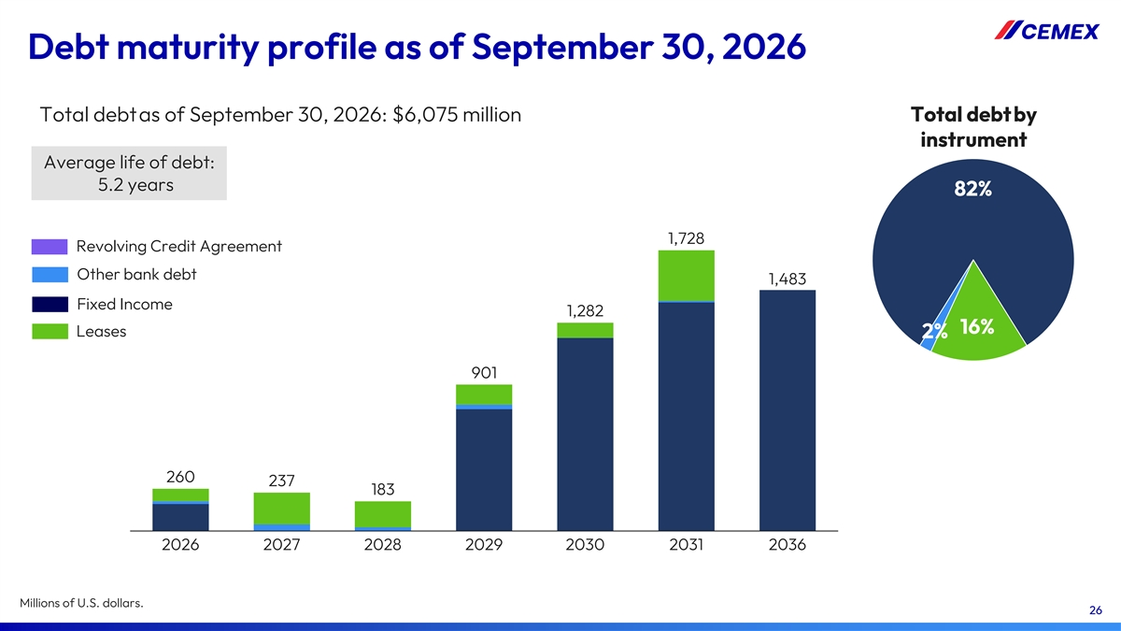
Debt maturity profile as of September 30, 2026 Total debtas of September 30, 2026: $6,075 million Total debt by instrument Average life of debt: 5.2 years 82% 1,728 Revolving Credit Agreement Other bank debt 1,483 Fixed Income 1,282 16% Leases 2% 901 260 237 183 2026 2027 2028 2029 2030 2031 2036 Millions of U.S. dollars. 26

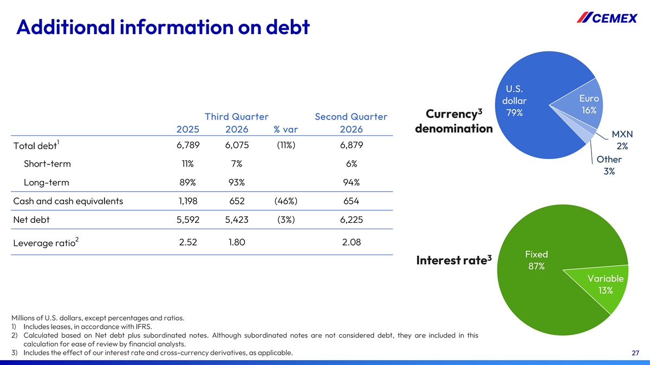
Additional information on debt U.S. Euro dollar 16% 3 79% Currency Third Quarter Second Quarter 2025 2026 % var 2026 denomination MXN 1 6,789 6,075 (11%) 6,879 Total debt 2% Other Short-term 11% 7% 6% 3% Long-term 89% 93% 94% Cash and cash equivalents 1,198 652 (46%) 654 Net debt 5,592 5,423 (3%) 6,225 2 2.52 1.80 2.08 Leverage ratio Fixed 3 Interest rate 87% Variable 13% Millions of U.S. dollars, except percentages and ratios. 1) Includes leases, in accordance with IFRS. 2) Calculated based on Net debt plus subordinated notes. Although subordinated notes are not considered debt, they are included in this calculation for ease of review by financial analysts. 3) Includes the effect of our interest rate and cross-currency derivatives, as applicable. 27

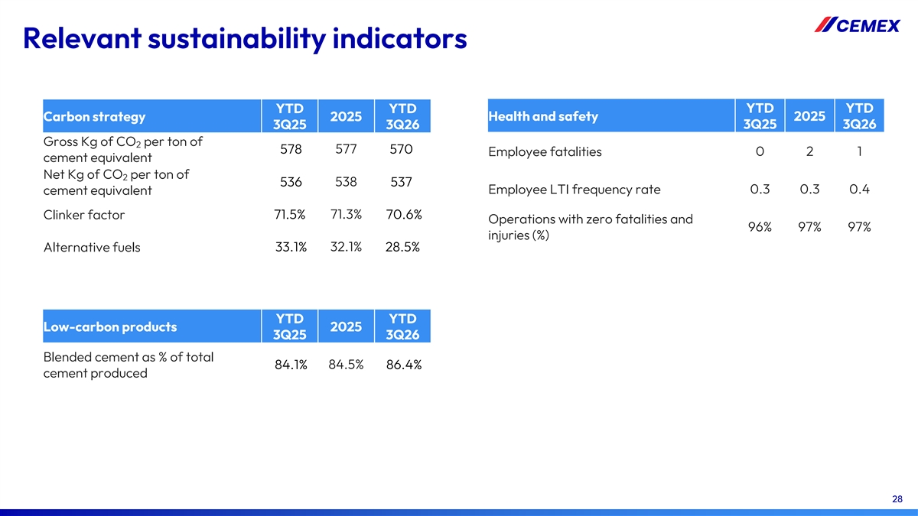
Relevant sustainability indicators YTD YTD YTD YTD Carbon strategy 2025 Health and safety 2025 3Q25 3Q26 3Q25 3Q26 Gross Kg of CO per ton of 2 578 577 570 0 2 1 Employee fatalities cement equivalent Net Kg of CO per ton of 2 536 538 537 Employee LTI frequency rate 0.3 0.3 0.4 cement equivalent 71.5% 71.3% 70.6% Clinker factor Operations with zero fatalities and 96% 97% 97% injuries (%) 33.1% 32.1% 28.5% Alternative fuels YTD YTD Low-carbon products 2025 3Q25 3Q26 Blended cement as % of total 84.1% 84.5% 86.4% cement produced 28

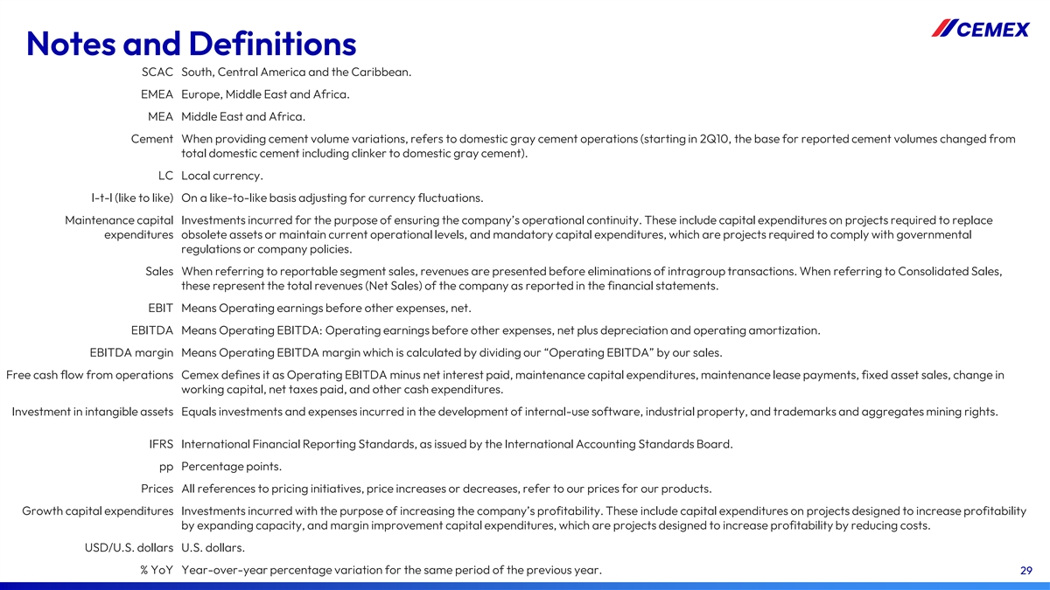
Notes and Definitions SCAC South, Central America and the Caribbean. EMEA Europe, Middle East and Africa. MEA Middle East and Africa. Cement When providing cement volume variations, refers to domestic gray cement operations (starting in 2Q10, the base for reported cement volumes changed from total domestic cement including clinker to domestic gray cement). LC Local currency. l-t-l (like to like) On a like-to-like basis adjusting for currency fluctuations. Maintenance capital Investments incurred for the purpose of ensuring the company’s operational continuity. These include capital expenditures on projects required to replace expenditures obsolete assets or maintain current operational levels, and mandatory capital expenditures, which are projects required to comply with governmental regulations or company policies. Sales When referring to reportable segment sales, revenues are presented before eliminations of intragroup transactions. When referring to Consolidated Sales, these represent the total revenues (Net Sales) of the company as reported in the financial statements. EBIT Means Operating earnings before other expenses, net. EBITDA Means Operating EBITDA: Operating earnings before other expenses, net plus depreciation and operating amortization. EBITDA margin Means Operating EBITDA margin which is calculated by dividing our “Operating EBITDA” by our sales. Free cash flow from operations Cemex defines it as Operating EBITDA minus net interest paid, maintenance capital expenditures, maintenance lease payments, fixed asset sales, change in working capital, net taxes paid, and other cash expenditures. Investment in intangible assets Equals investments and expenses incurred in the development of internal-use software, industrial property, and trademarks and aggregates mining rights. IFRS International Financial Reporting Standards, as issued by the International Accounting Standards Board. pp Percentage points. Prices All references to pricing initiatives, price increases or decreases, refer to our prices for our products. Growth capital expenditures Investments incurred with the purpose of increasing the company’s profitability. These include capital expenditures on projects designed to increase profitability by expanding capacity, and margin improvement capital expenditures, which are projects designed to increase profitability by reducing costs. USD/U.S. dollars U.S. dollars. % YoY Year-over-year percentage variation for the same period of the previous year. 29

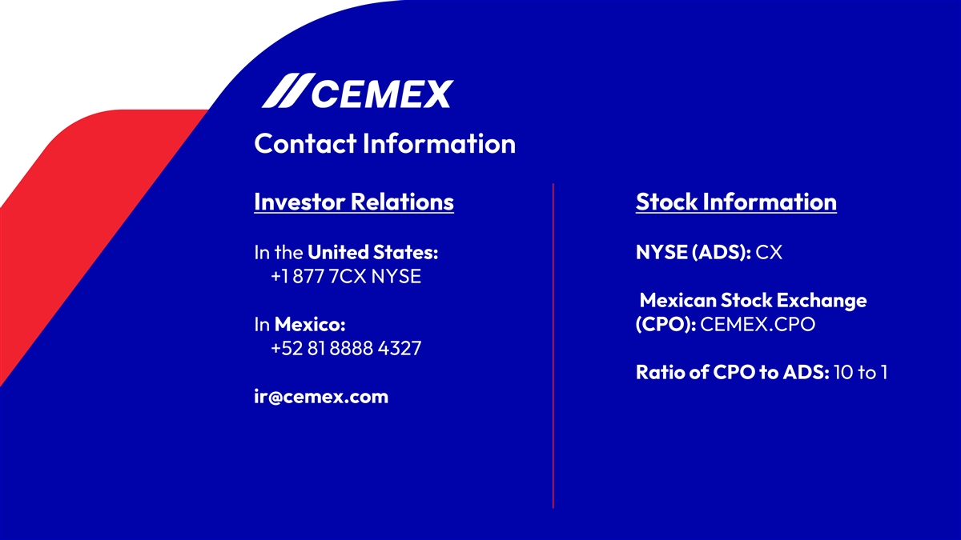
Contact Information Investor Relations Stock Information In the United States: NYSE (ADS): CX +1 877 7CX NYSE Mexican Stock Exchange In Mexico: (CPO): CEMEX.CPO +52 81 8888 4327 Ratio of CPO to ADS: 10 to 1 ir@cemex.com

